University Of Engineering And Technology Peshawar
Submitted To: Sir Kifayatullah
Submitted By: Ahmad Jamal
Subject: Communication Systems (LAB REPORTS)
Registration: 17PWELE5076
Section: A
Semester: 8th

LAB NO 01:
Observation of double side Band with Suppressed carrier.

Apparatus:
- Carrier source
- Modulator
- Signal Generator
- Oscilloscope
- Spectrum Analyzer

Definition:
In amplitude modulation, we vary the amplitude of the carrier signal in accordance with the message signal, which is of lower frequency and lower amplitude than that of the carrier signal amplitude.
Similarly, in amplitude modulation using Double side band we use suppressed carrier which is folded between upper side band and lower side band such type of modulation is known as double side band modulation with suppressed carrier.

Procedure:
First of all we arrange all the devices required to conductthe experiment in correct order. Similarly, we are observing double side band which has further upper side and lower side band. In experiment we modulated a signal, which we usually considered as a message signal.
We observe them on oscilloscope in continuous time domain but we have also observed the same signal in frequency domain, by using spectrum analyzer where we observed suppressed Carrier.
The problem with communication with the help of modulated signals with suppressed carrier is that it need a simple transmitter and drop also. But it need very complicated and expensive receiver. While in multitasking it can be marked as feasible,but in board- casting it is not feasible.

Block Diagram:
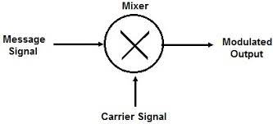

Waveform of AM with suppressed Carrier:

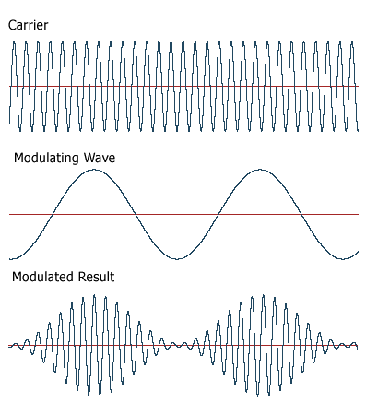

LAB NO 02:
Observation of Amplitude Modulation with Full carrier.

Apparatus:
- Carrier source
- Modulator
- Signal Generator
- Oscilloscope
- Spectrum Analyzer

Definition:
The type of modulation in which we use double side band but the carrier is not suppressed is called double side band with full carrier. Similarly, in amplitude modulation of the carrier signal which is a high frequency signal in accordance with the amplitude of message signal, which is of lower frequency and amplitude than of the carrier frequency and amplitude.

Procedure:
In amplitude modulation we can have the full carrier. This help us in designing complex and expensive transmitters while cheap and simple receivers. This method is broadly used in board-casting. For this experiment we first arrangedall the devices and instruments in order and then we connected them in proper order according to the block diagram.
When we modulated message signal with the help of modulator then we studied it through oscilloscope in continuous time domain. To study the frequency components of the modulated signal we use spectrum analyzer where the carrier isnot suppressed but it is a full carrier. Amplitude modulation needs very high power transmitter.

Block Diagram:
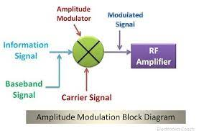
Waveform of Amplitude Modulation with Full Carrier:
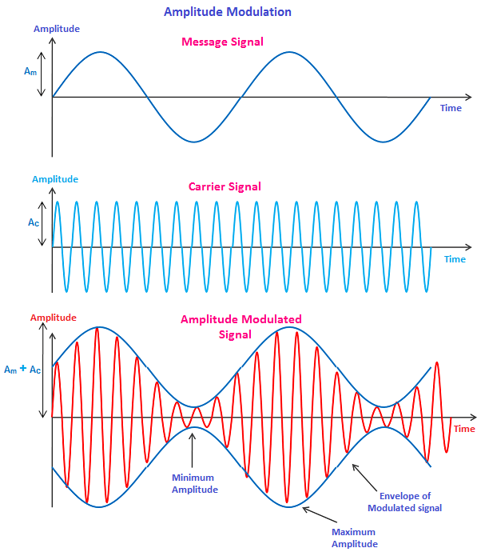

LAB N0 03:
Demodulation of AM using Envelop detector

Apparatus:
- Carrier source,
- Balanced Modulator
- Modulation source
- Envelop Detector

Definition:
The amplitude modulation signal utilizes the amplitude of message signal to modulate high frequency carrier signal. Therefore, when we receive the amplitude modulated signal, we need to restore the message signal. Normally envelop detector uses asynchronous detection.
Procedure:
Since amplitude modulation signal utilizes message signal to modulate carrier signal,which means the variation of carrier signal amplitude is followed by the change of message signalamplitude. Hence the objective of amplitude demodulator is to take out the variation envelope detection from modulated AM signal. Thiscircuit is a typical asynchronous detector. It rectifies the modulated AM signal and obtains a positive half wave signal. After that, the signal will pass through a low-pass filter and obtain envelope detection. Then get rid of the DC signal, the message signal will be recovered.

Block Diagram and Waveform:
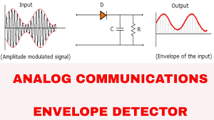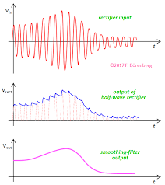
LAB N0 04:
Demodulation of AM using Product detector

Apparatus:
- Carrier source,
- Balanced Modulator
- Modulation source
- BFO (Beat frequency oscillator)
- Product detector

Definition:
The modulated signal spectrum centered at carrier frequency of USB and LSB where this scheme does not contain a discrete component of carrier frequency is observed by Spectrum analyzer.

Procedure:
A DSB scheme is generated from a carrier source and a modulating signal. In the same way the same carrier is multiplied at Demodulator using BFO and the Passed through envelope detector, Product detector and then results are analyzed with Spectrum analyzer. Local carrier is Multiplied using BFO finally the signal is detected using Product detector.

Block Diagram:

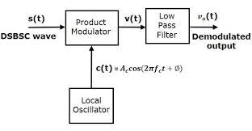
LAB NO 05:
Generation of Single Side Band from Double Side Band.

Apparatus:
- Signal Generator
- Modulator
- Carrier source
- LSB Filter
- USB Filter
- Oscilloscope
- Spectrum Analyzer

Definition:
As we know DSB is not BW efficient which needs more BW for same information. So we need another scheme which is called SSB and it is BW efficient.

Procedure:
the generator is a balance modulator producing DSB following by a band pass filter for the required side band- to have a good shape factor because of normal carrier and frequencies, USB and LSB are quite close in frequency domain when observe on analyzer. So for USB we use high pass filter and for LSB we use low pass filter.

USES AND ADVANDTAGES:
- It is used for transmission through radio links.
- It transmitter requirement is also very low.

Block Diagram for SSB Generation:
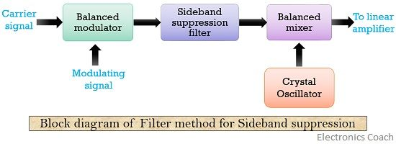
Waveform:
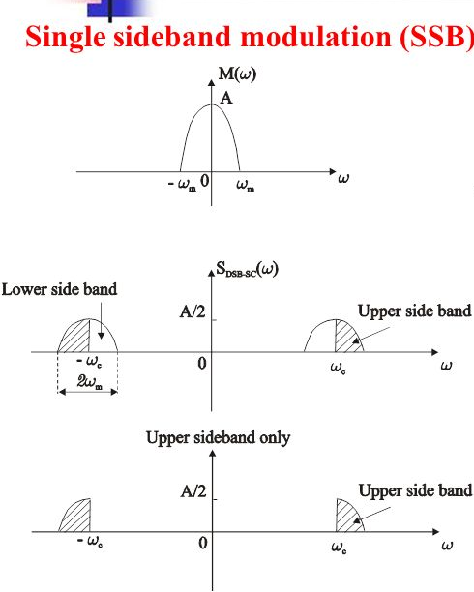

LAB NO 06:
Demodulation of SSB using Product Detector.

Apparatus:
- Signal Generator
- Modulator
- Carrier source
- LSB Filter
- USB Filter
- Product Detector
- BFO (Beat Frequency Oscillator)
- Oscilloscope
- Spectrum Analyzer

Definition:
It is a basically the reverse process to retrieve the transmitted message.

Procedure:
DSB Demodulation was done using BFO to reinsert the carrier. The BFO was in phase with the original carriers. But for Demodulation we need same frequency we can use both USB and LSB and see that with BFO set correctly near to the original carrier. Frequently even through the side bandsare at different frequencies. The demodulated output is same changing BPO frequency causes the demodulated changing BFO frequency must changes frequency in same amount.

Uses and Advantages:
SSB is one of the most powerful technique transmitting audio frequencies over radio links with its narrow BW and Efficient use of adorable transmitted power

Block Diagram:
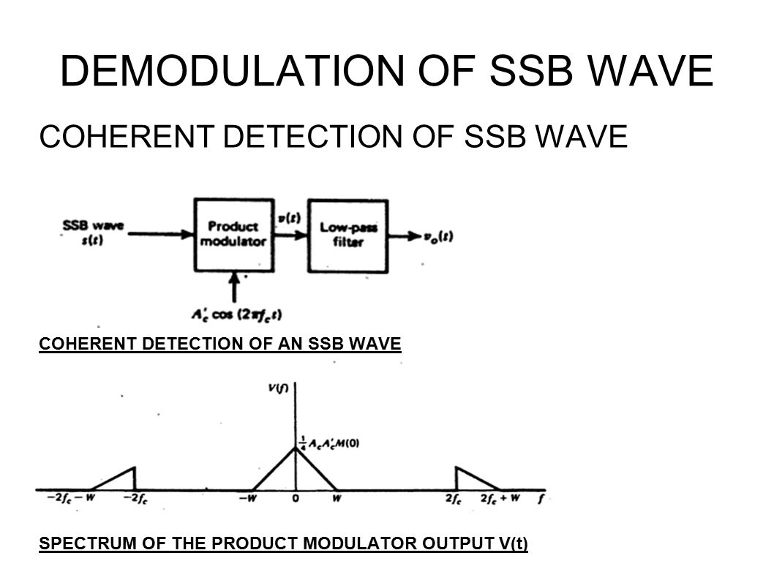

LAB NO 07:
To Study Frequency Modulation.

Apparatus:
- Carrier source
- Modulation Source
- Frequency Modulator
- Oscilloscope
- Spectrum Analyzer

Definition:
In Frequency Modulation, the frequency of the carrier signal is varied according to the amplitude of the message signal but keeping the amplitude of the carrier signals constant,

Procedure:
Using modulation source message signal is obtained. Similarly carrier signal is also generated by the carrier source. FM produces frequency modulated signal. By comparing FM and AM both acquire the same BW but FM quality is better than AM.
FM has two main types
- NWFM (narrow band FM)
- WBFM (wide band FM)

Block Diagram and Waveform:
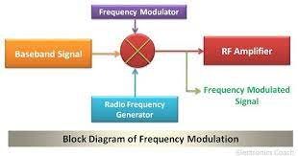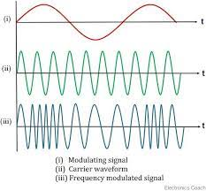
LAB NO 08:
Demodulation of FM Signal using Phase Loop Lock.

Apparatus:
- Carrier source
- Modulation Source
- Frequency Modulator
- Oscilloscope
- Spectrum Analyzer
- Phase Detector
- Filter
- Output Filter
- VCO(voltage Control Oscillator)

Procedure:
As we know PLL trace and angle the instantaneous value of the incoming signal. The Modulation source provides the message signal. The frequency of Modulator produce frequency modulated signals VCO (voltage control oscillator) provides the feedback signal and input to VCO is output to the output filter. The Loop made by phase detector filter and VCO is called PLL.

Block Diagram:

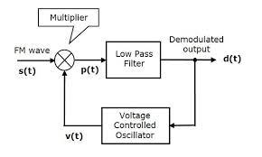

LAB N0 09:
To analyze super heterodyne AM receiver

Apparatus:
- RF Antenna
- RF Filter
- RF amp
- IF Filter
- IF amp
- Envelope Detector
- Product Detector
- BFO (Beat frequency oscillator)
- Spectrum Analyzer

Definition:
Super heterodyne receiver is used for Demodulation of A.M waves. It’s basically consists of aw antenna which receives Electromagnetic waves, a radio frequency amplifier, a mixer and local oscillator, intermediate frequency amplifier, Detector, Audio amplifier and a Speaker.

Procedure:
It is basically a receiver. The RF section is basically a tunable filter and aw amplifier that picks the desired station by tuning the filter to right frequency band. The frequency mixer translates the carrier WC to a fix. If frequency of 455 KHz for this purpose a local oscillator is used Flo= (fc+Fif) where Fif is up conversion. The tuning of local oscillator and RF tunable filter is by one knob. This means that every station is tuned to a fix frequency. If the section suppressed the adjacent channel, it has high selectivity amplifier signals for amplifier detection. The next is to detect message signal which was modulated at transmission side. After the message signal is received its power is very small which is further amplified by audio amplifier which can be a common bias or voltage divider bias and at the end message signal is provided to a speaker.

Block Diagram and Waveform:

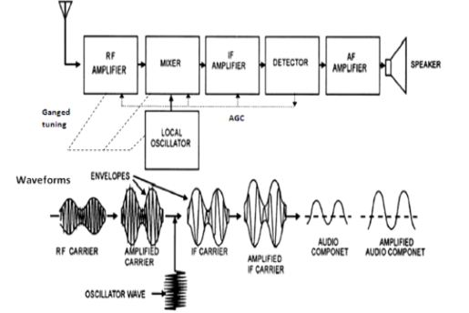

LAB N0 10:
To analyze super heterodyne FM receiver

Apparatus:
- Antenna
- RF Mixer
- RF amp
- IF Filter
- IF amp
- Limiter
- LPF and BPF
- Spectrum Analyzer

Definition:
Super heterodyne FM receiver is used for Demodulation of FM waves. It basically consists of an antenna, BF mixer, IF filter, If amplifier, limiter, FM demodulation, LP, Band pass, Audio amplifier, and speaker.
It has a Range from 88 MHz to 108 MHz
It has a channel Separation of 200 KHz and intermediate frequency of 10.7 MHz

Procedure:
First of all we generated a message signal of 2.4 KHz and then we translated it to high frequency for transmission by using a high frequency carrier lies in 88 – 108 MHz, then the same Modulated signals is provided to a Demodulator which could easily demodulate. FM wave is modulated with the message signal. The signal was received by the antenna section then subsequently provided to the intermediate section of frequency which transformed it to constant frequency of 10.7 MHz

Block Diagram and Waveform:

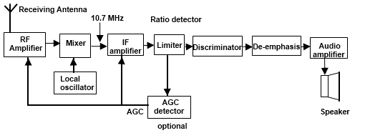
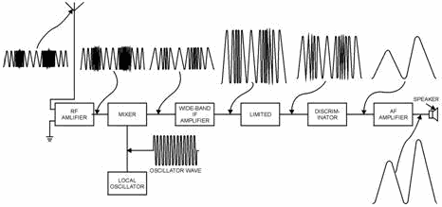

LAB N0 11:
Sending and Receiving of Binary Data Requirement

Apparatus:
- Data sender Module DCS 297A
- Data receiver module DCS 297H
- Connecting wires

Procedure:
I connect 16KHZ clock to clock W of Data source module.
Data source position: Put format switch on 8 Bit position, connect the data source to data receiving module by connecting bit clock out.
If data source module is set to the bit clock of data receiver module and then clocks are grounded.
Also connect NRZ data out of the data source module to NRZ data in of data receiver module. Now press data switches on the data source module according to which the Bit stream needs to be sent. The Led will light up according to their position. We observe that the Led of data receiving module also grow According to their position. The bits are sent serially from source to receiver module.

Block Diagram:
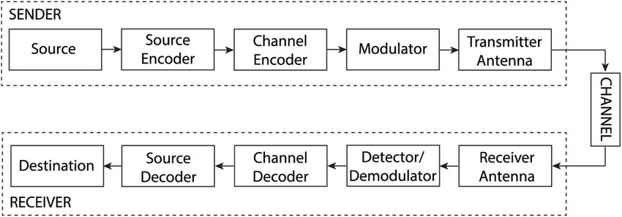

LAB N0 12:
To establish a ADA link

Apparatus:
- Data source Module DCS 297A
- Data receiver Module DCS 297H
- Connecting wires
- Two microphone speaker Module DCS 297K
- Power supply

Procedure:
First of all I connected data source module to data receiver module. I got receiver module from microphone source output of data receiver module to the inputSpeaker. The analogue input from microphone is converted to digital data by ADC at the data source module. The Digital data is sent serially to the data receiver module where it converted back to analogue signal and given to speaker. This conversion is from Digital to analogue data takes place at the data receiver module by DAC.

Block Diagram:
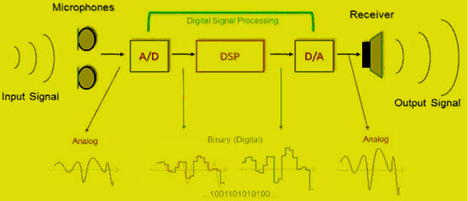

LAB NO 13:
To study Different Data formats or coding Schemes

Apparatus:
- Data source module 297A
- Data format module DCS 297B
- Power supply
- Connecting wires
- Oscilloscope

Procedure:
First of all i connected data source module to the data receiving module, gave some stream of bits to data source module. This data is sent to data module.
We have applied the data stream of bits 01011000 from data source module. The oscilloscope is connected to various format outputs and we observe the Spectrum pattern.

Waveform:
