Experiment No: 1
To Analyse 3- Phase (Resistive, Capacitive and Inductance) Balanced Loads
In this experiment variables of different load resistances are measured and recorded:
- Resistive load
- Inductive load
- Capacitive load
Three phase systems are derived from three separate windings, either connected in delta or star (wye). Each winding can be treated separately, leading to the idea that the load in each winding can be viewed independently.
The conductors between a voltage source and a load are called lines, and the voltage between any two lines is called line voltage. The voltage measured between any line and neutral is called phase voltage.
In a three-phase system feeding a balanced and linear load, the sum of the instantaneous currents of the three conductors is zero. In other words, the current in each conductor is equal in magnitude to the sum of the currents in the other two, but with the opposite sign. The return path for the current in any phase conductor is the other two phase conductors.
In a perfectly balanced case all three lines share equivalent loads. Examining the circuits, we can derive relationships between line voltage and current, and load voltage and current for wye and delta connected loads.
In a balanced system each line will produce equal voltage magnitudes at phase angles equally spaced from each other. With V1 as our reference and V3 lagging V2 lagging V1, using angle notation, and VLN the voltage between the line and the neutral we have,
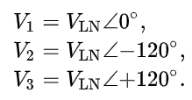
Star Configuration
The voltage seen by the load will depend on the load connection; for the wye case, connecting each load to a phase (line-to-neutral) voltages gives
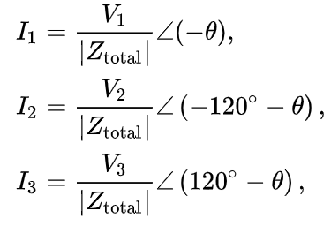
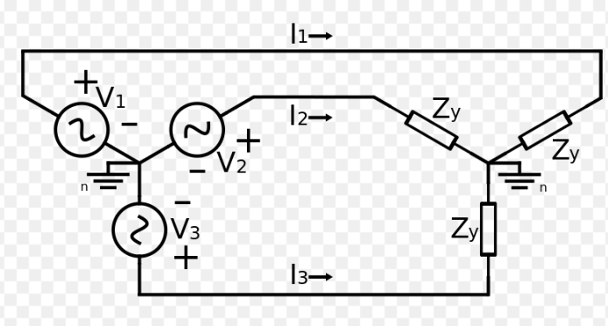
where Z_{total} is the sum of line and load impedances (Z_{total} = ZLN + ZY), and θ is the phase of the total impedance (Z_{total}).
The phase angle difference between voltage and current of each phase is not necessarily 0 and is dependent on the type of load impedance, Z_{y}. Inductive and capacitive loads will cause current to either lag or lead the voltage. However, the relative phase angle between each pair of lines (1 to 2, 2 to 3, and 3 to 1) will still be −120°.
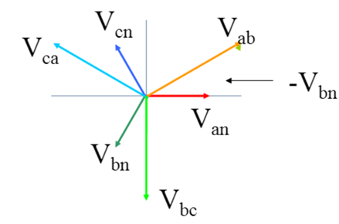
Resistive Load
Setup the Circuit as follows
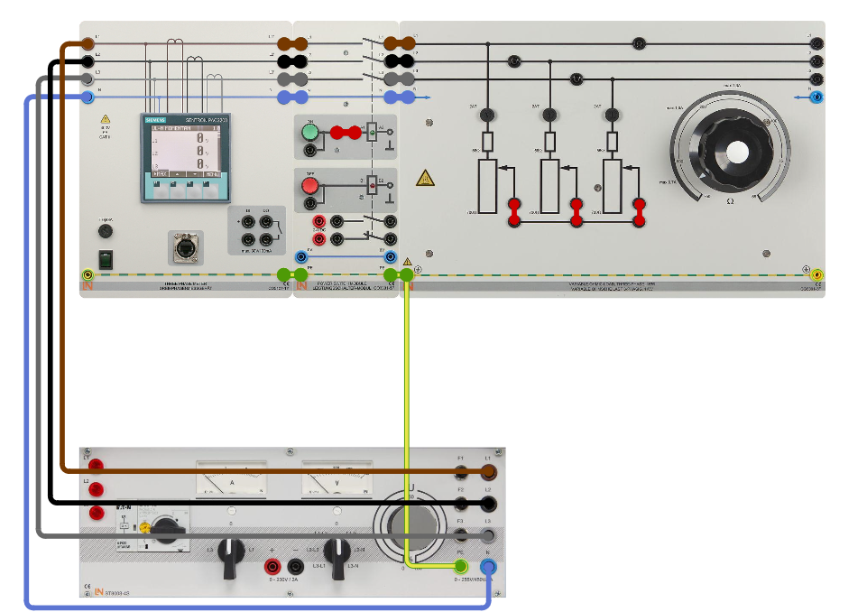

Procedure
- Connect the resistor in star configuration set it to a level of 750 Ω
- Switch on the variable three-phase power supply and set the phase voltage to 230 V.
- Turn the power switch CO3301-5P ON
- You can read all the values directly from the power quality meter.

Inductive Load
Setup the Circuit as follows
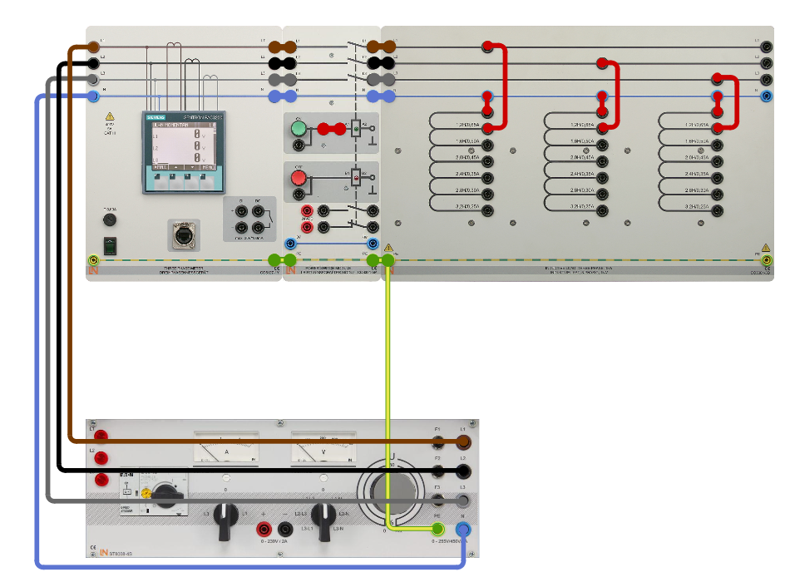

Procedure
- Connect the inductive load in star configuraiton and set this to levels of 1.2 H, 2 H and 3.2 H in succession
- Switch the variable three-phase power supply on and set it to a voltage of 400 V
- Turn the power switch CO3301-5P ON
- You can read all the values directly from the power quality meter.
Reactance X_{L} = Q_{L} / I²_{1N}
Capacitive Load
Setup the Circuit as follows

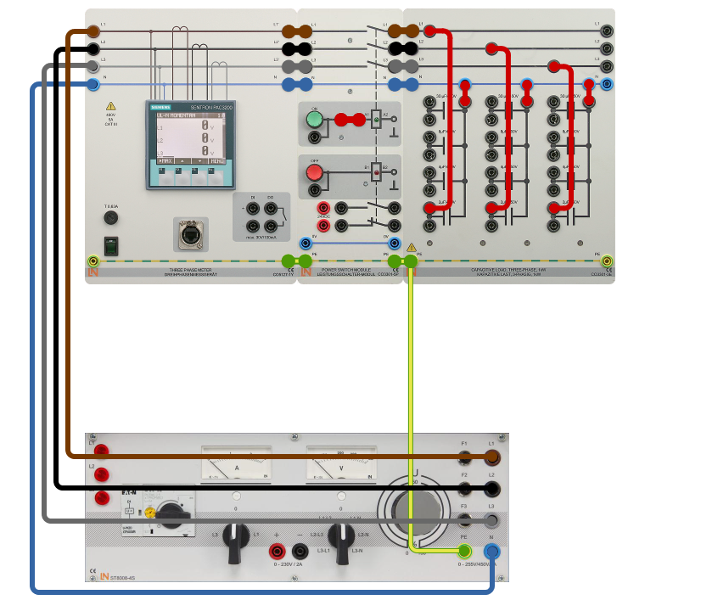

Procedure
- Connect the capacitive load in star configuration and set it to 2 µF, 4 µF and 8 µF in succession one after the other
- Switch on the variable three-phase power supply and set the phase voltage to 230 V
- Turn the power switch CO3301-5P ON
- You can read all the values directly from the power quality meter.
Reactance X_{C} = U_{1N} / I_{1N}

Delta Configuration
A phasor diagram for a wye configuration, in which Vab represents a line voltage and Van represents a phase voltage. Voltages are balanced as: Vab = (1∠α − 1∠α + 120°) √3 |V|∠α + 30° Vbc = √3 |V|∠α − 90° Vca = √3 |V|∠α + 150° (α = 0 in this case.)
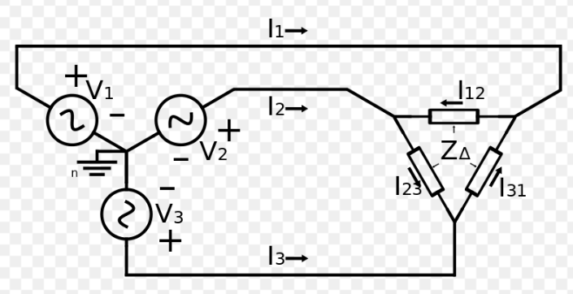
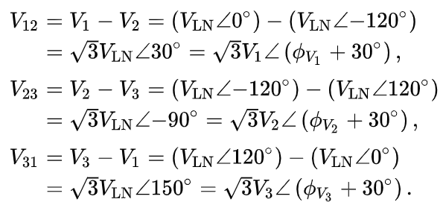
Resistive Load
In the delta circuit, loads are connected across the lines, and so loads see line-to-line voltages.

Setup the Circuit as follows
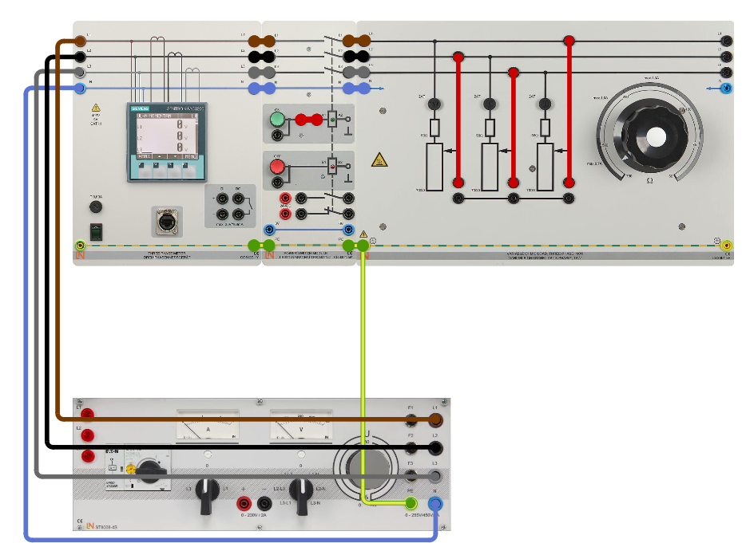

Procedure
- Connect the resistor in delta configuration and set the resistance value to 750 Ω
- Switch on the variable three-phase power supply and set the phase voltage to 230 V.
- Turn the power switch CO3301-5P ON
- You can read all the values directly from the power quality meter.
Inductive load
Setup the Circuit as follows
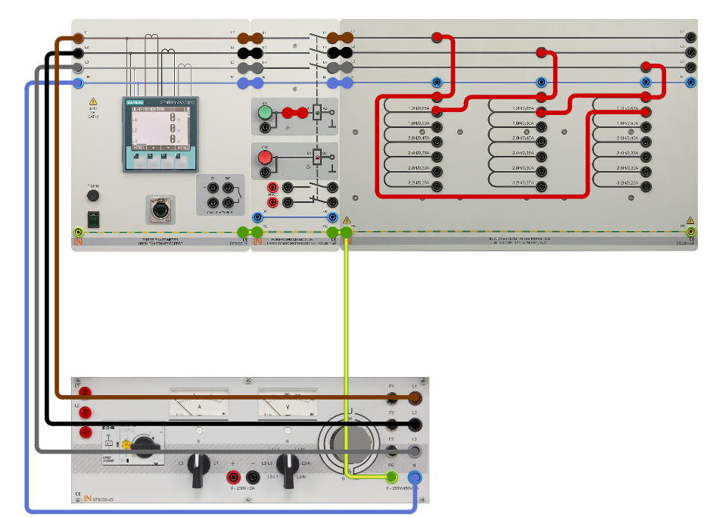

Procedure
- Compute the maximum line-to-line current I1. The phase-to-phase current is I_{phmax} = 0.65
I_{1max} = √3 * I_{phmax}
- Switch on the variable transformer and set the line-to-line current to I₁ = 1 A.
- Turn the power switch CO3301-5P ON
- You can read all the values directly from the power quality meter.
Reactance X_{L} = Q_{L} / I_{1max}²
Capacitive Load
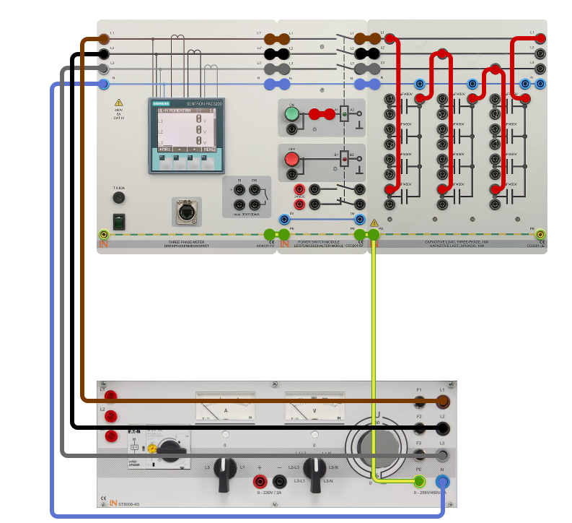

Procedure
- Connect the capacitive load in star configuration and set the capacitance to 2 µF
- Switch on the three-phase power supply and set the phase voltage to 230 V
- Turn the power switch CO3301-5P ON
- You can read all the values directly from the power quality meter.
Reactance X_{C} = U_{1N} / I_{1N}

Experiment No: 2
To Analyse 3- Phase (RL, RC, RLC) Balanced Loads
In this experiment variables of various resistances are measured and recorded:
- RL series connection
- RC series connection
- RLC series connection
RL Series Configuration
Setup the Circuit as follows
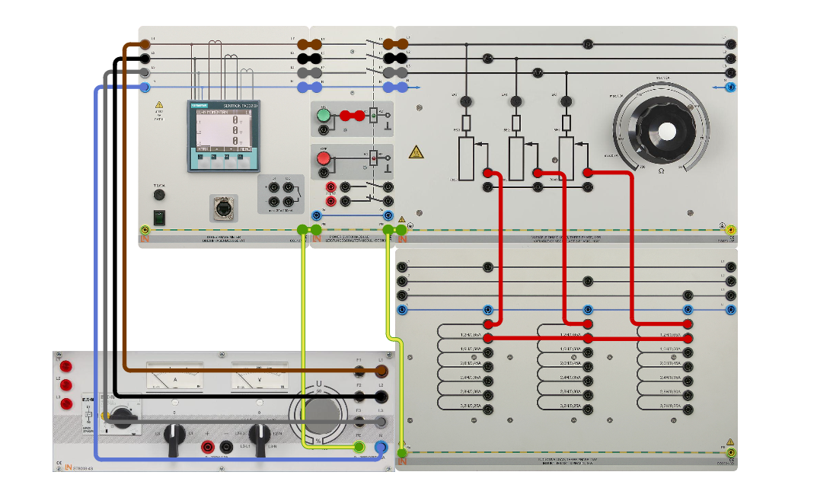

Procedure
- Connect the resistive load (750 Ω) in series to the inductive load in star configuration and set the following inductance levels 1.2 H, 2 H and 3.2 H in succession one after the other
- Switch on the variable transformer and set a phase voltage of Uph = 230 V
- Turn the power switch CO3301-5P ON
- You can read all the values directly from the power quality meter.
Reactance X_{L} = Q_{L} / I²_{1N.}
RC Series Configuration
Setup the Circuit as follows
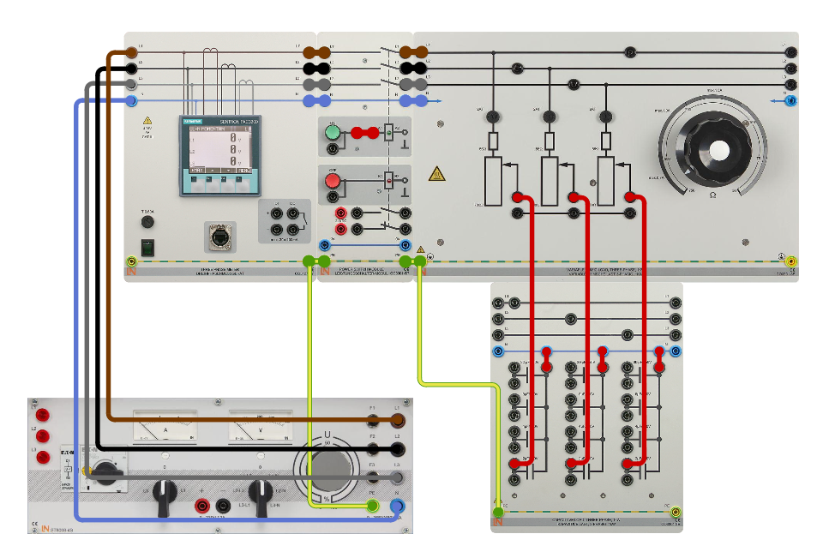

Procedure
- Connect the resistive load with a resistance of 750 Ω in series with the capacitive load in star configuration and set the capacitance to 2 µF, 4 µF and 8 µF one after the other
- Switch the variable three-phase power supply on and set the phase voltage to 230 V
- Turn the power switch CO3301-5P ON
- You can read all the values directly from the power quality meter.
Reactance X_{C} = Q_{C} / I²1_{N.}

RLC Series Configuration
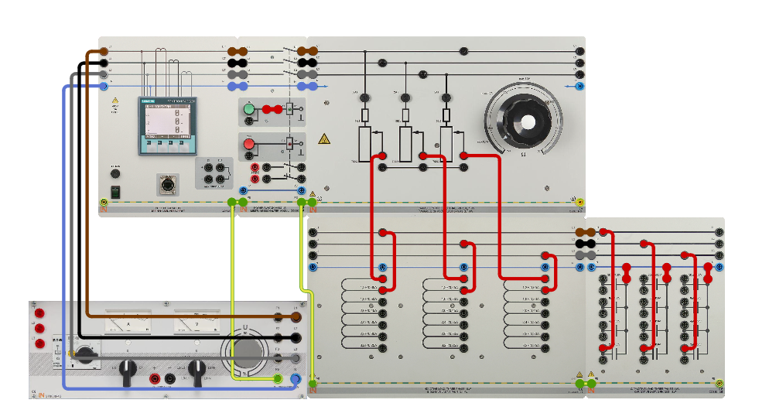

Procedure
- Connect the resistive load (750 Ω) in series with the capacitive load (4 μF), and this in series with the inductive load (1.2 H) connected in star configuration.
- Switch on the variable three-phase power supply and set a phase voltage of 230 V.
- Turn the power switch CO3301-5P ON
- You can read all the values directly from the power quality meter.
Reactance X_{LC} = Q_{LC} / I²1_{N}

Experiment No: 3
To Analyse 3- Phase dynamic load (Asynchronous Motor)
An important class of three-phase load is the electric motor. A three-phase induction motor has a simple design, inherently high starting torque and high efficiency. Such motors are applied in industry for many applications. A three-phase motor is more compact and less costly than a single-phase motor of the same voltage class and rating, and single-phase AC motors above 10 HP (7.5 kW) are uncommon. Three-phase motors also vibrate less and hence last longer than single-phase motors of the same power used under the same conditions.
It may be observed that the rotor speed should not reach the synchronous speed produced by the stator. If the speeds become equal, there would be no such relative speed, so no emf induced in the rotor, and no current would be flowing, and therefore no torque would be generated. Consequently, the rotor cannot reach the synchronous speed. The difference between the stator (synchronous speed) and rotor speeds is called the slip. The rotation of the magnetic field in an induction motor has the advantage that no electrical connections need to be made to the rotor.
In this experiment variables of dynamic load such as Asynchronous motor, are measured and recorded.
Setup the Circuit as follows

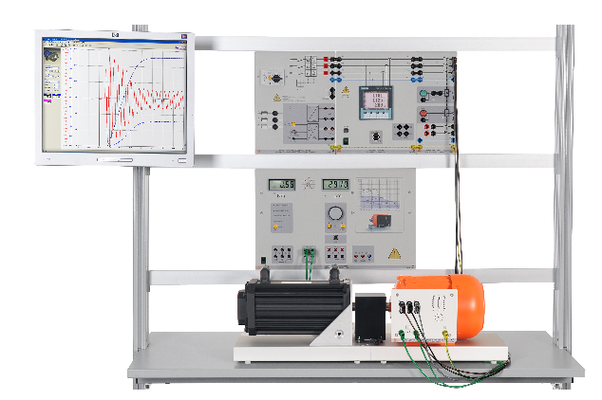

Procedure
- Connect the dynamic load (Motor) in star configuration star configuration.
- Switch on the variable transformer and set a phase voltage of Uph = 230 V
- Turn the power switch CO3301-5P ON
- You can read all the values directly from the power quality meter.
Observations and Calculations
Measure the following Values:
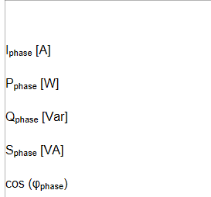

Experiment No: 4
Investigation of No Load operation of a 3-Phase Transformer
In this experiment No Load operation of Transformer is analysed
Initially, the transformer is operated with no load, then with a short circuit to establish its parameters. An investigation of the different types of load (resistive, inductive, capacitive) is then conducted.
Two digital multimeters can be used to measure the relevant variables of voltage, current plus active and reactive power on the primary and secondary sides simultaneously. An additional voltmeter is needed to measure the voltage during the short-circuit measurement, because the multimeter is not able to display such small voltage values.
The rated apparent power for the transformer is 1 kVA. This means that the rated current on the primary side is as follows:
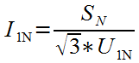
In all experiments, it must be ensured that the calculated current I1N=1.44 A is not significantly exceeded (due to circuit faults, for example). The transformer also benefits from an automatic circuit breaker providing protection against prolonged overload of its windings.
In order for the experiment to return reproducible results, you should work with a constant input voltage of 400 V (except in the case of the short-circuit measurement). It is therefore advisable to use the infinitely adjustable transformer at a constant output voltage of 400 V in all measurements.
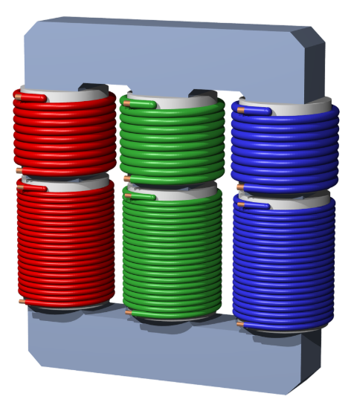

Setup the Circuit as follows
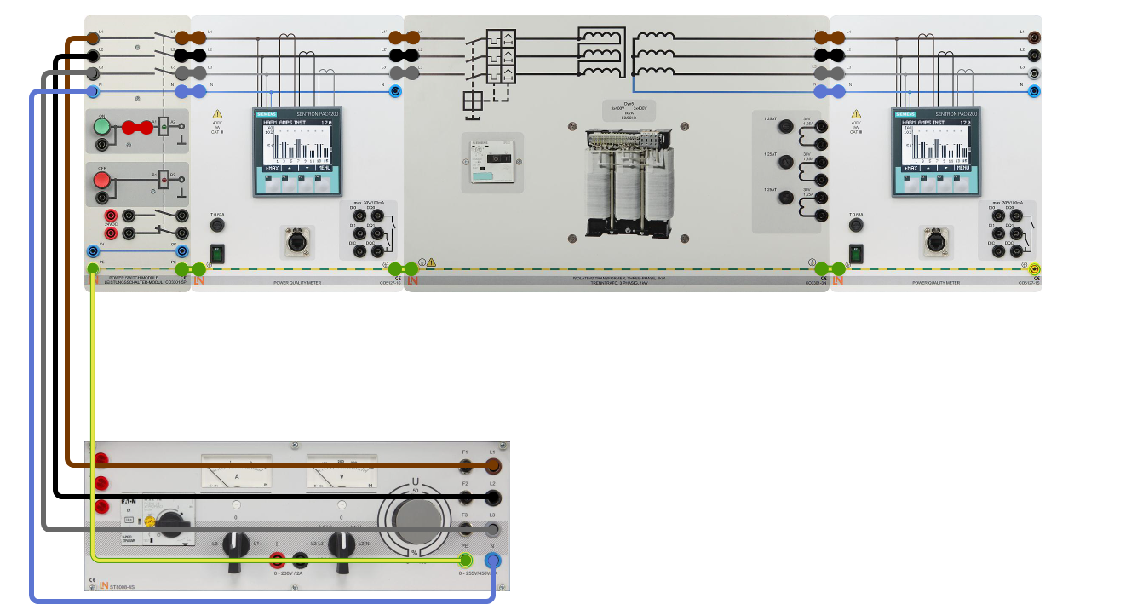

Procedure
- Make the connections as shown in the figure above.
- Turn the power switch CO3301-5P ON
- You can read all the values directly from the power quality meter.

Observations and Calculations
The variables listed in the table are to be measured (in the following, the power levels are always three-phase values, i.e. total power levels).
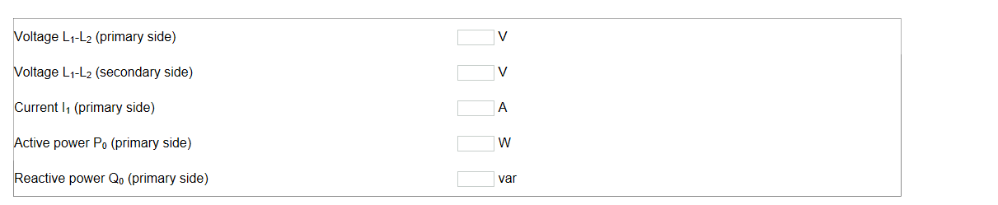

Experiment No: 5
Investigation of a 3-Phase Transformer when Different Loads are connected
In this experiment operation of Transformer is analysed when different types of loads are connected i.e.
- Resistive Load
- Capacitive Load
- Inductive Load
Initially, the transformer is operated with no load, then with a short circuit to establish its parameters. An investigation of the different types of load (resistive, inductive, capacitive) is then conducted.
Two digital multimeters can be used to measure the relevant variables of voltage, current plus active and reactive power on the primary and secondary sides simultaneously. An additional voltmeter is needed to measure the voltage during the short-circuit measurement, because the multimeter is not able to display such small voltage values.
The rated apparent power for the transformer is 1 kVA. This means that the rated current on the primary side is as follows:
In all experiments, it must be ensured that the calculated current I1N=1.44 A is not significantly exceeded (due to circuit faults, for example). The transformer also benefits from an automatic circuit breaker providing protection against prolonged overload of its windings.
In order for the experiment to return reproducible results, you should work with a constant input voltage of 400 V (except in the case of the short-circuit measurement). It is therefore advisable to use the infinitely adjustable transformer at a constant output voltage of 400 V in all measurements.

Resistive Load:
Setup the Circuit as follows

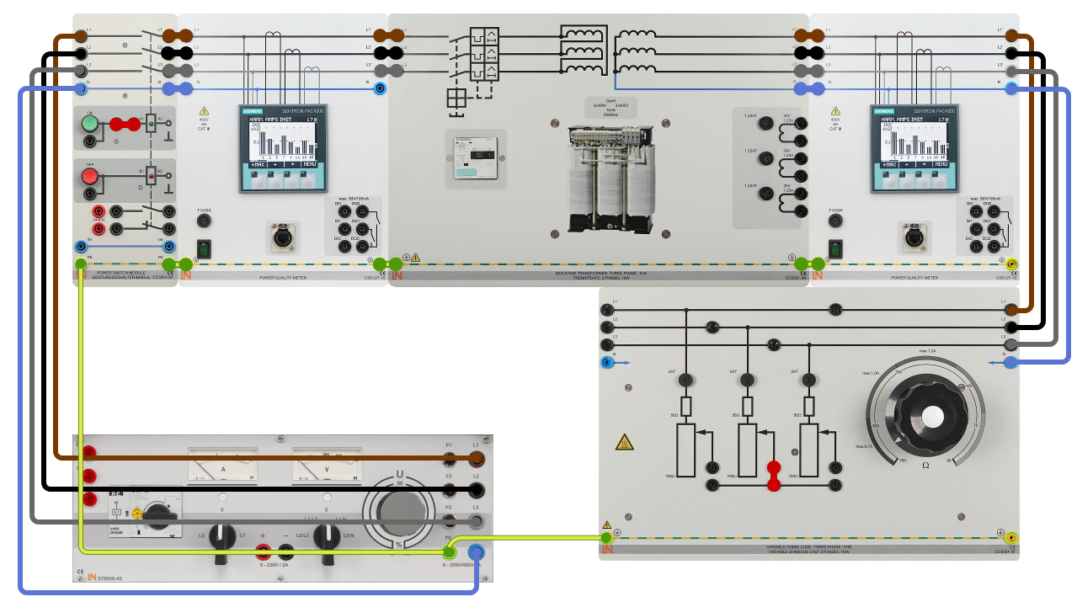

Procedure
- Make the connections as shown in the figure above.
- Starting from the highest value, vary the load resistance such that the currents indicated in the table flow on the primary side.
- Measure/calculate the following variables:
U₁ = 400 V = constant

Observations and Calculations
Measure/calculate the following variables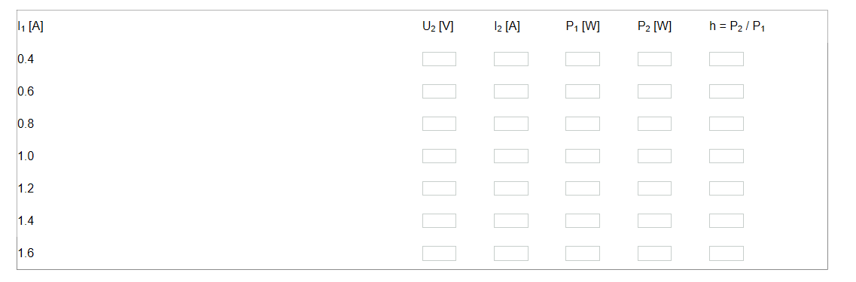
Inductive Load:
Setup the Circuit as follows

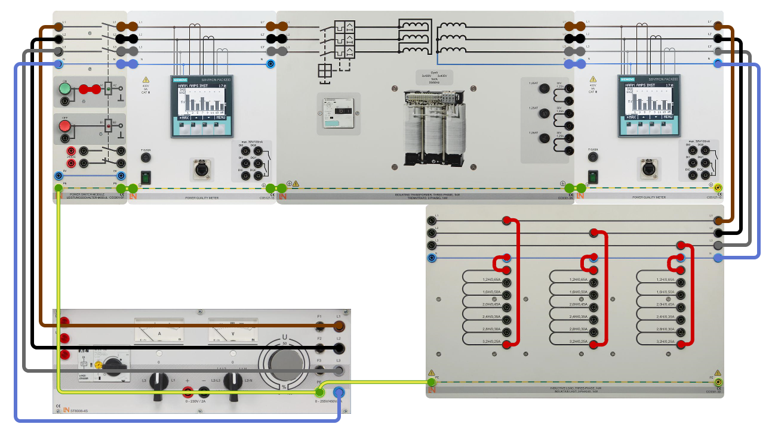

Procedure
- Make the connections as shown in the figure above.
- Measure/calculate the following variables:
U₁ = 400 V = constant
Observations and Calculations
Measure/calculate the following variables
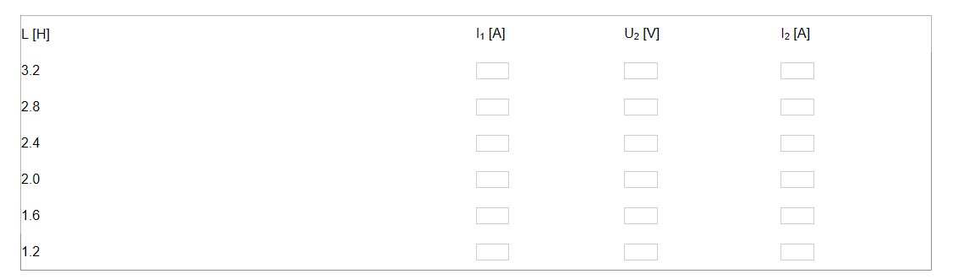
Capacitive Load:
Setup the Circuit as follows
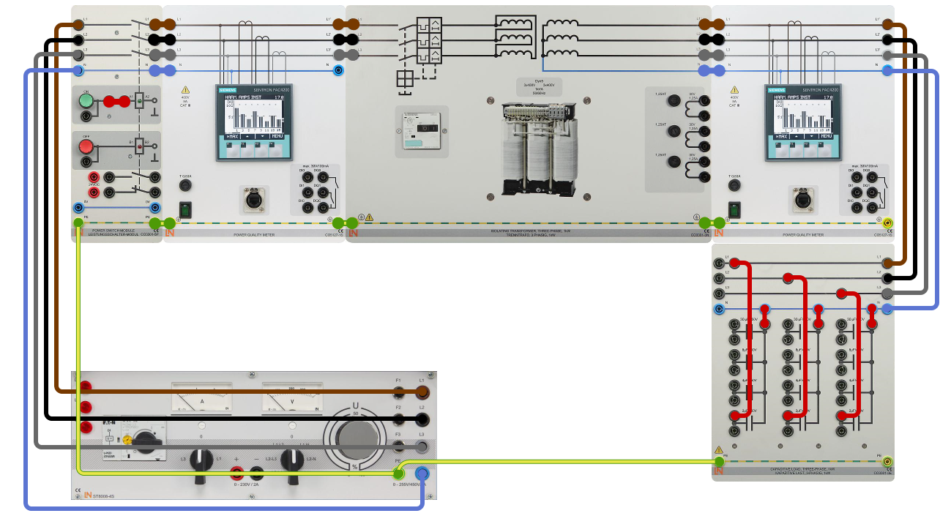

Procedure
- Make the connections as shown in the figure above.
- Measure/calculate the following variables:
U₁ = 400 V = constant
Observations and Calculations
Measure/calculate the following variables
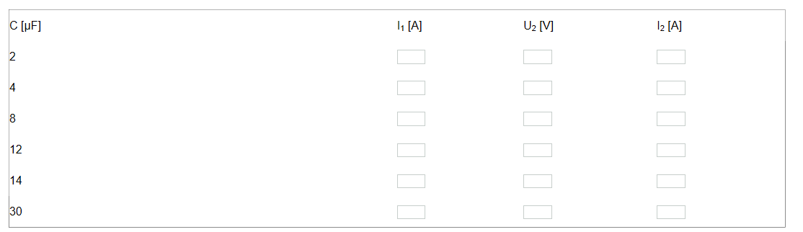

Experiment No: 6
Investigation of a 3-Phase Overhead Line
In this experiment three phase transmission line is analysed.
A line's behavior in the steady state can be described by means of the characteristic parameters comprising resistance, inductance and capacitance. The expression "line" serves as a general term for overhead lines and underground cables which basically exhibit the same behavior. The three characteristic parameters just mentioned represent constants which apply at any point along the length of the line (quantities per unit length). At the lengths of 100 – 400 km typical of extra-high voltage lines, however, concentrations of elements can be considered without any significant losses in accuracy, thus resulting in the following three-phase equivalent circuit diagram:
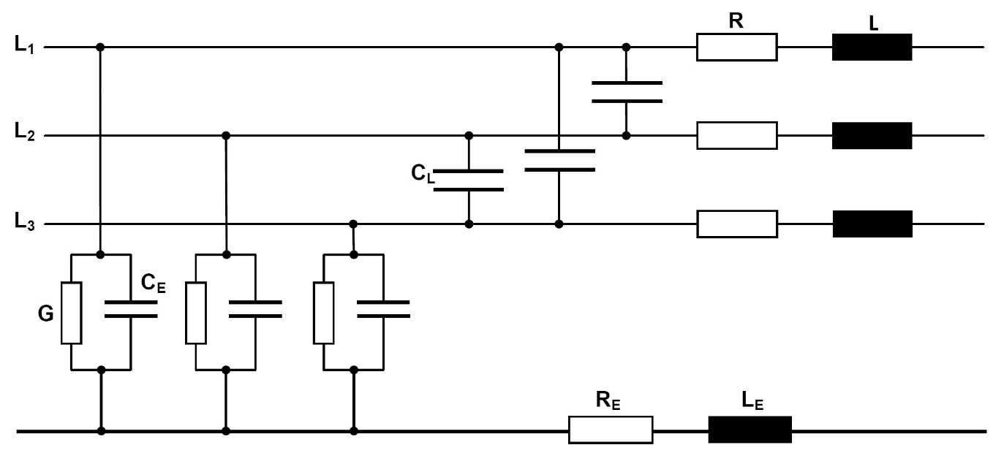
Figure: Three-phase equivalent circuit diagram of a power transmission line comprising concentrated elements
The active resistance R is determined by the conductor's material, cross-section and, naturally, length. The inductance L accounts for the magnetic field generated when a current flows through a conductor loop. A distinction is made between two types of capacitance: The line-to-line capacitance C_{L} is the capacitance between any two outer conductors, while C_{E} is the capacitance between the outer conductors and earth. The dissipation losses caused by leakage currents and, in particular, corona losses at high currents, are described by the conductance G. Finally, the characteristics of the return conductor (earth, earth wire) are represented by means of the parameters R_{E} and L_{E}. The line model consists of a 380-kV overhead line comprising groups of four and possessing a cross-section of 4 x 300 mm² (aluminium). The model has the following longitudinal data (constants):
R’ = 0.024 Ω / km, L’ = 0.77 mH / km, C_{B}’ = 13.07 nF / km.
Single-phase representation is sufficient if the operating conditions are symmetric (identical voltages and currents for the three outer conductors). The line and earth capacitances at various voltages are converted into a new variable designated the effective or working capacitance C_{B}. In this case: C_{B} = C_{E} + 3 C_{L}. It must be noted that underground cables have a much higher working capacitance than overhead lines. Regardless, representation with the help of a Π-element is more advantageous than the T-type equivalent circuit diagram shown above, the transverse elements being applied in a proportion of half each at the beginning and end of the diagram. This results in the following representation:
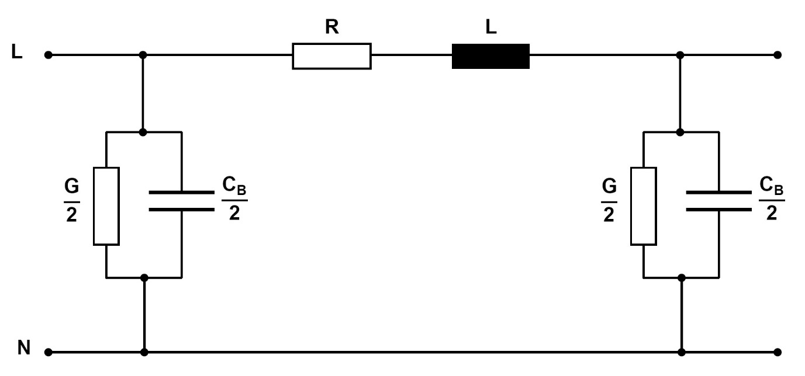
Figure: Single-phase equivalent circuit diagram of a line
To keep transmission losses within limits, efforts are made in practice to minimize the conductor resistance R and maximize the conductance G. Accordingly, R << ωL and G >> ωC_{B}.
Lines with these properties are described as low-loss. If R and G can be neglected entirely, one speaks of a lossless line. Though lossless lines cannot be realized in practice, the simplifications above become more accurate as the considered voltage level rises. This applies especially when investigating the steady-state response. For rough calculations confined to essential aspects, the equivalent circuit diagram shown below can be used to represent operation at zero power loss.
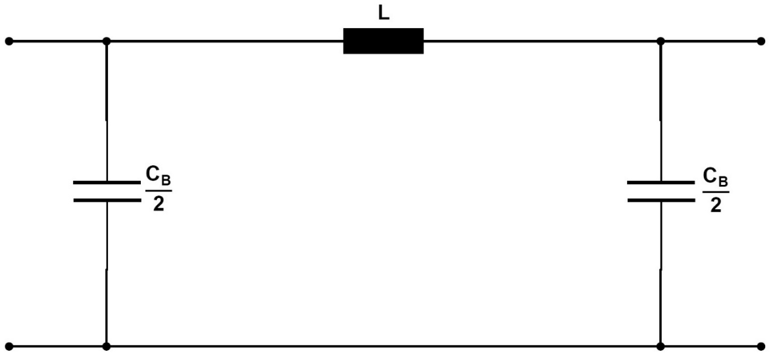
Figure: Single-phase equivalent circuit diagram of a lossless line.
For further investigations (e.g. determination of efficiency and transmission losses), it is necessary to at least consider the active resistance as well as R. For exact modelling (e.g. when investigating processes involving travelling waves), a line of length l should be composed of an infinite number of π--elements each with a differential length of dl. This representation can be used to derive line equations needed for precise calculations of long lines. These equations include a factor designated characteristic impedance Z_{w}. Assuming a lossless line, this factor is calculated using the equation Z_{W} = √ (L / C_{B}). If a line is subjected to a resistive load equal in magnitude to the characteristic impedance, one speaks of matching. This state is ideal in terms of transmission losses. A variable load resistor at the end of the line can be used to clearly demonstrate the three states comprising no-load, matching and (symmetric) short circuit.

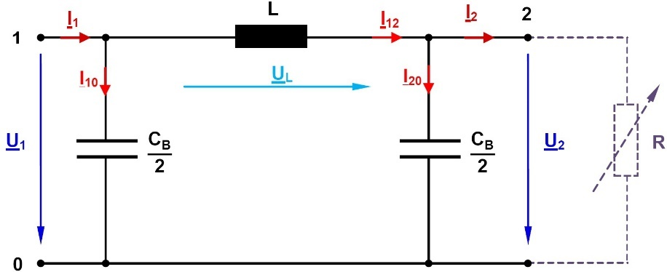 | R=∞ → no-load  R=Z_{w} → Matching  R=0 → Short circuit
Figure: Lossless line in various load states
In the case of single-phase representation, it is always necessary to account for star voltages, i.e. those occurring between a phase and the neutral point (the voltage measured between two outer conductors is designated line-to-line voltage U_{Δ} here). On transition to a three-phase system, all powers calculated in the single-phase representation must be multiplied by a factor of 3 to obtain the total power. The designations listed below are used (complex variables are underlined).
U₁, U₂: Voltages respectively at the line's start and end
U_{L} : Voltage drop along the line
I₁, I₂: Currents respectively at the line's start and end
I₁₀, I₂₀: Currents through the transverse branches respectively at the line's start and end
I₁₂ : Current through the line's longitudinal branch
In the no-load state, the terminating resistance R at the line's end is infinitely large, so that the current I₂ = 0. The processes taking place in circuits operating at sinusoidal voltages are visualized by means of phasor diagrams. These diagrams enable a simultaneous representation of the magnitude and phase angle of the AC quantities under examination. Phasors can be added or subtracted graphically, thereby allowing a clear display, for instance, of voltage drops in networks. All phasors rotate at an angular speed denoted by ω, their diagrams serving to provide "snapshots" of the system under consideration. These displays are purely of a qualitative nature and not true-to-scale, and therefore only intended for illustration. The related, numerical values can be determined individually with the help of complex calculations. In the combined current/voltage phasor diagrams below, the voltage vector at the end of the line is defined arbitrarily as the reference phasor, and drawn in the same direction as the real axis. Furthermore, as is common practice in energy technology, the display's coordinate system is rotated by +90° so that the real axis points in the y-direction. The current/voltage phasor diagram below describes the no-load state.
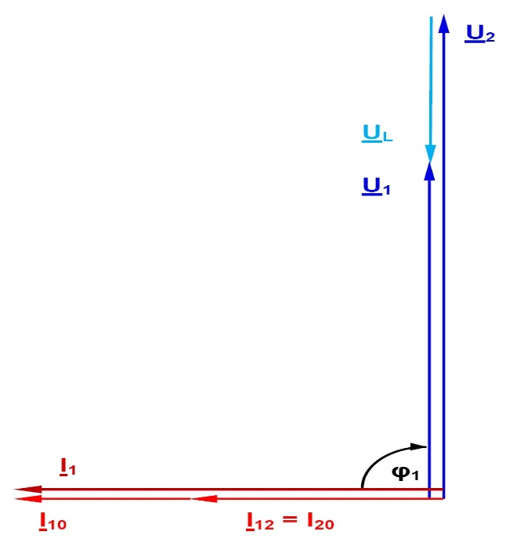
Figure: Current/voltage phasor diagram of a lossless line in the no-load state
The phasor diagram shows that in this operating state, the voltage at the line's end is higher than the voltage at the line's start. This is due to the working capacitance and known as the Ferranti effect. The voltage at the line's end has risen disproportionately with respect to the line's length; efforts are therefore made to avoid this operating state in practice. The current flowing in the no-load state is termed the charging current, and the associated reactive power the charging power. As already mentioned, underground cables have a higher working capacitance than overhead lines. The effects described earlier are much more pronounced here. In the event of matching, the load resistance R is exactly equal to the characteristic impedance. The power consumed by the active resistance is termed natural power. The resultant current is just high enough so that the reactive power consumption attributable to the line inductance is exactly equal to reactive power generated by the working capacitance. Assuming that the line is lossless, it consumes or generates no reactive power whatsoever, and the active power it draws from the upstream connected network only amounts to the natural power. Furthermore, the voltage at the start of the line in this case has the same magnitude as the voltage at the end of the line. The next phasor diagram describes this situation.
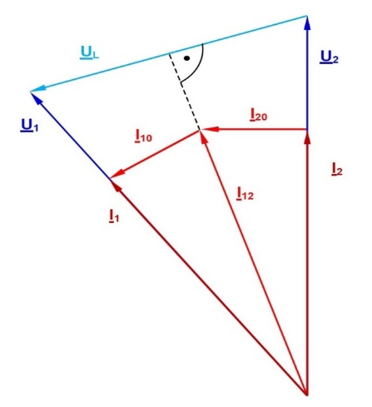
Figure: Current/voltage phasor diagram of a lossless line during matching (termination with the characteristic impedance)
Due to the conductive material of which it is made, every real transmission line also has an active resistance, which is responsible for the transmission losses. These are equal to the difference between the supplied and consumed powers. A transmission system's efficiency is defined as the ratio between the active powers at the system's output and input. Because no reactive power needs to be transmitted in the event of matching, the efficiency is maximized in this case. Since the value of a line's load is determined by the behaviour of the consumers connected to the line, matching occurs very rarely and randomly. However, reactive power compensation is also available as an option for minimizing transmission losses. Related experiments are described in the chapter after the next one. In the case of a (three-pole) short circuit,the load resistance R has the value 0. The current then flowing is limited only by the line impedance (assuming that the line inductance results in lossless transmission) and therefore much higher than the values occurring during normal operation. This must be detected and isolated as soon as possible by the network protection devices. The phasor diagram below describes this situation.
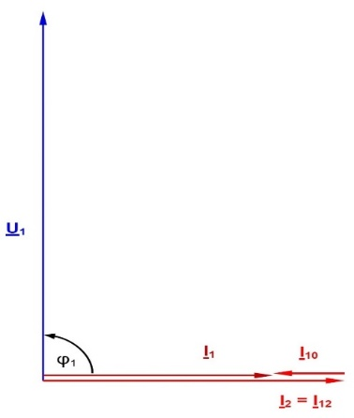
Figure: Current/voltage phasor diagram of a lossless line in the event of a short circuit at the line's end
Finally, we will look at the phasor diagram in the case of the resistive/inductive loads such as those occurring most frequently during real-life operation. For a more precise representation, a low-loss line is assumed here.
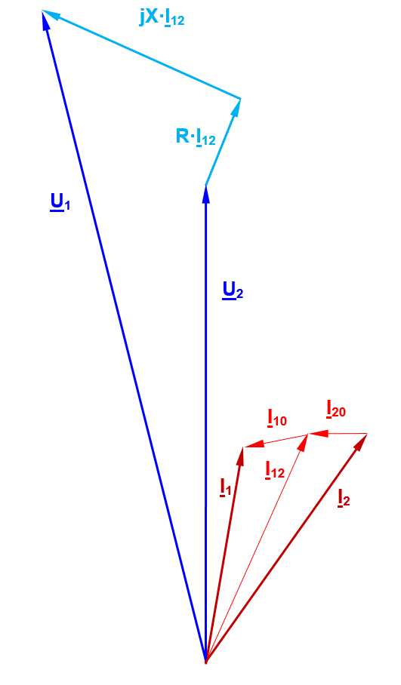
Figure: Current/voltage phasor diagram of a low-loss line in the case of a mixed (resistive/inductive) load
The resultant current I₂ through the load comprises a resistive and an inductive component in accordance with the ratio of the load's active and reactive powers. In practice, the influence of the capacitances at the line's end is (qualitatively) lower than that indicated in the phasor diagram here, i.e. I₂ and I₁₂ are approximately equal. As the reactive power rises, so does the longitudinal current through the line and, consequently, the losses produced by the line resistance R. To minimize these losses, electricity supply companies define certain limiting values for the reactive power and power factor cos φ. Accordingly, it is common to demand a surcharge on electricity rates (reactive power clause) from cos φ values below 0.8. One alternative for the customer is to compensate the (usually) inductive reactive power by means of capacitors connected in parallel. The power triangle shown below illustrates the relationships involved here.
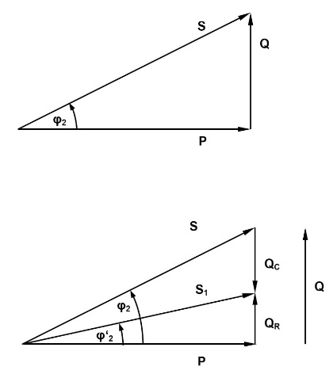
Figure: Power ratios with an uncompensated and partly compensated load
P is the active power, Q the reactive power, and S the apparent power. To reduce the apparent power and, consequently, the apparent current, the reactive power can be lowered, for instance, from its original value Q to a residual value Q_{R}. This is equivalent to improving the power factor from cos φ₂ to cos φ'₂. As indicated in the diagram, the compensatory reactive power Q_{C} needed for this is therefore:
Q_{C} = P * (tan φ₂ - tan φ'₂), where P is the total consumed active power.
The equation indicates that the compensatory capacitance is load dependent. Its three individual capacitors C connected in star configuration are determined by:
C = Q_{C} / (ω * U_{N}²)
The last equation assumes that the nominal voltage is present across the load. Moreover, half the working capacitance present at the line's end also contributes very slightly toward compensation. However, both influences are usually ignored during the design of compensatory mechanisms. For full compensation, φ'₂ must be zero, so that: Q_{C} = P * tan φ₂.
Usually, it is sufficient to perform compensation leaving a residual reactive power at which a surcharge for reactive work is just avoided. Besides this parallel compensation (of relevance to consumers), there is also the possibility of series compensation in the case of very long lines. Performed by the transmission network's operator, this kind of compensation is meant to reduce the effect of the longitudinal conductivity L and, therefore, the voltage drop U_{L}.
The next phasor diagram illustrates the action of series compensation (to simplify the working capacitance was dropped).
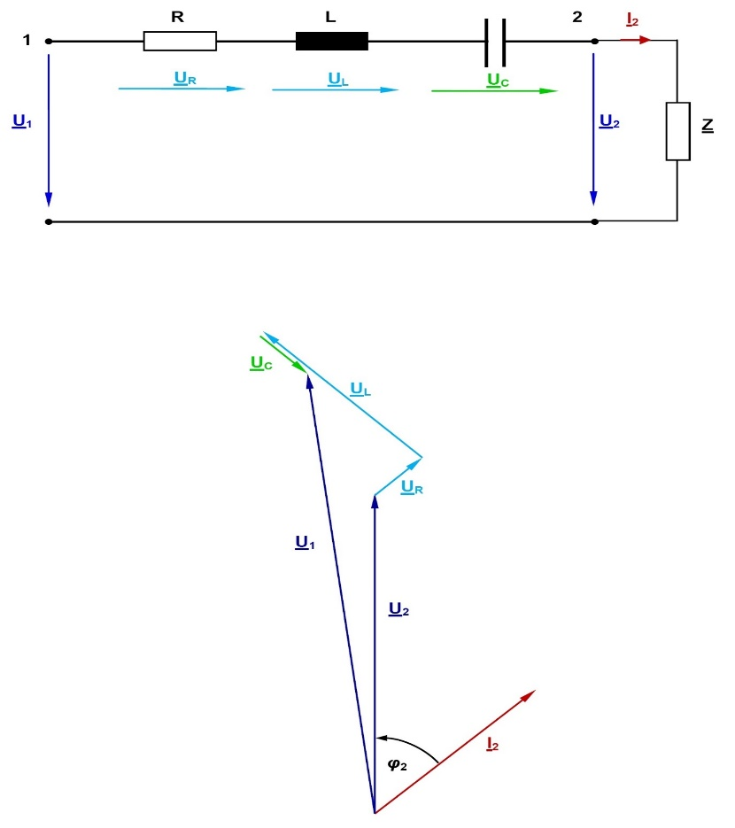
Figure: Series compensation: Circuit diagram and associated phasor diagram
For the sake of simplicity, the line capacitances are not considered because they have practically no influence on the process of compensation. If the entire voltage drop U_{L} is to be compensated, the three capacitors C must have the following value:
C = 1 / (ω² * L) = 1 / (ω * X_{L})
In practice, only partial compensation is often performed to a level of 30% – 60 % (capacitor reactance in relation to line reactance X_{L}). Wherever possible, the three capacitors are positioned roughly halfway between the two line ends.
Procedure:
Simulated first in these experiments are the three operating states comprising no-load, matching and short-circuit for the two line lengths of 150 and 300 km. Two multimeters can be used to simultaneously measure all voltages and currents as well as active, reactive and apparent powers at both line ends. The feed transformer's voltage at the start of the line is to be increased in steps to the specified value in each case. In this process, make sure that the maximum permissible values of the voltage (400 V between two outer conductors phases) and current (2.5 A during short circuit) are not exceeded anywhere.
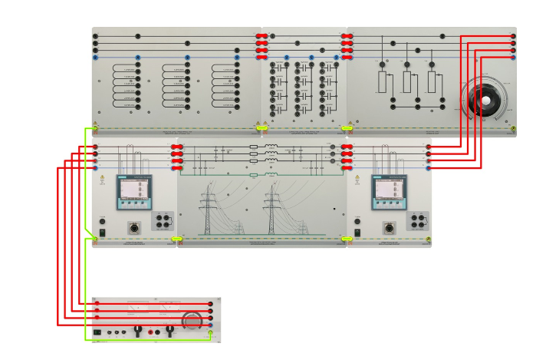
- Set up the circuit as illustrated next.
- Disconnect the resistive load to study operating response under no-load.
For both line lengths, set the voltage to the nominal value (380 V) at the beginning of the line. The outer conductors are designated L₁ , L₂ and L₃ , the neutral conductor N. Measure the variables indicated in the table (the powers always comprise three-phase values, i.e. total power levels):
Observations and Calculations:
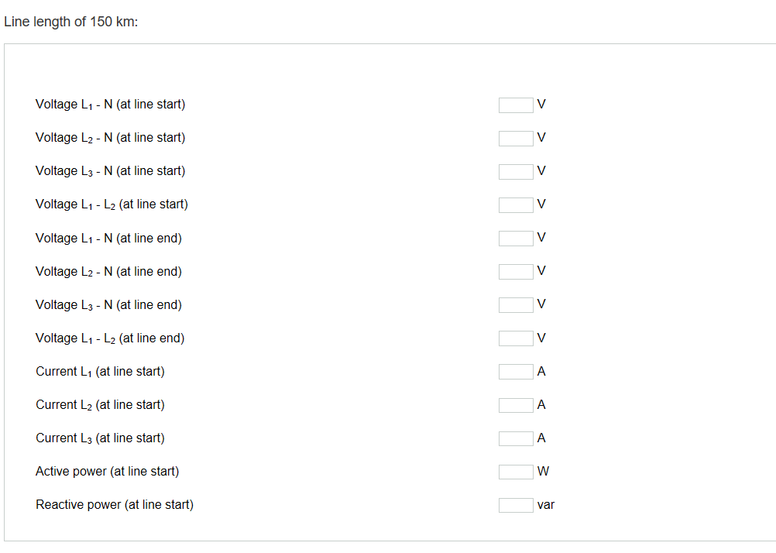
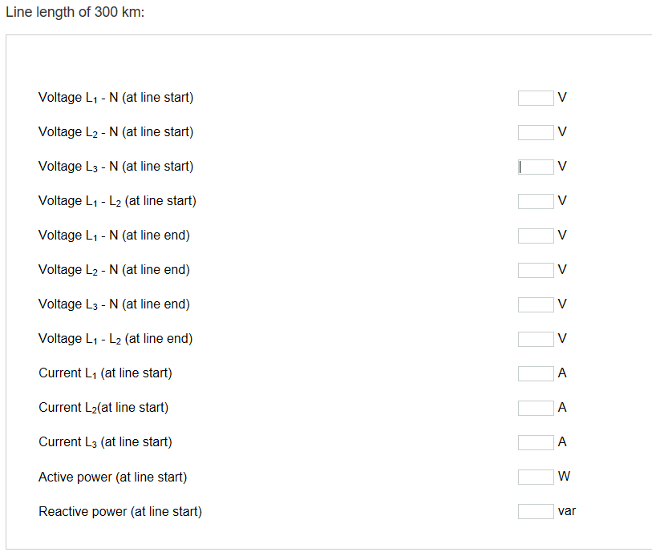

Experiment No: 7
Parallel and Series Connection of a Transmission Line
In this experiment parallel and series connection of a Transmission line are analysed.
To derive the laws governing series and parallel connections of transmission lines, it is first necessary to know the equivalent circuits of the involved components. In investigations confined to trouble-free operation, the line's three phases are loaded symmetrically. In this case, it is sufficient to consider a single phase representation in the form of a π-element shown in Figure.
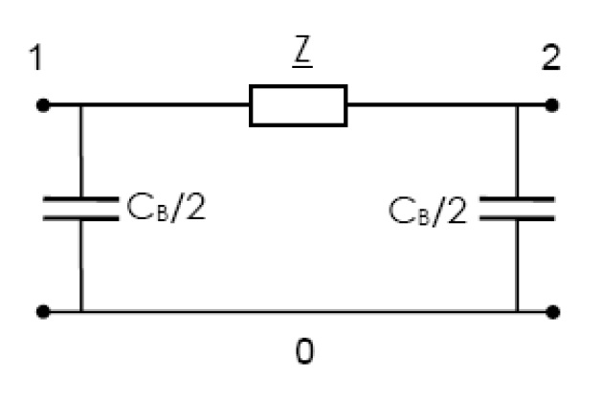
Figure 1: Equivalent circuit of a transmission line (single-phase representation)
The longitudinal impedance Z is comprised of the line resistance R and line inductance L. It is calculated with the equation Z = R + j X, where X = ωL. The working capacitance C_{B} is applied in two equal halves each to the start and end of the line to avoid an additional node in the middle of the line.
In reality, these parameters are distributed evenly as constants over the line's entire length. Details and figures on the constants are provided in the experiment titled "Investigating three-phase lines".
The equivalent circuit diagram above reflects the situation sufficiently accurately, as long as only steady-state operating conditions are considered and the lines are not excessively long.
The line models used in the experiments are designed as three-phase π-networks with possible lengths of 150 and 300 km. The specific values (constants) of the employed lines are: R'= 0.024 Ω/km, X' = 0.241 Ω/km and C_{B}'= 13.33 nF/km. To demonstrate typical properties, it is sufficient to consider a transmission path terminated by means of a mixed, resistive-inductive load. In principle, the findings obtained here also apply to other types of load. A resistive-inductive load results in the phasor diagram shown below, indices 1 and 2 respectively indicating the line start and end, 0 representing the return conductor (earth).
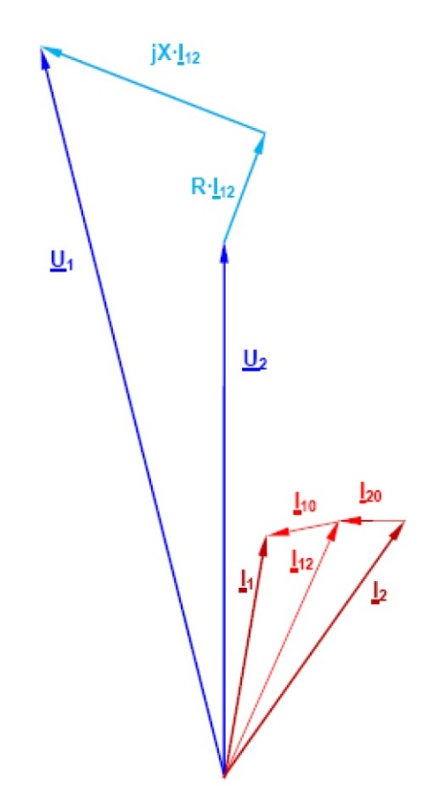
Figure 2: Phasor diagram of a line with a resistive-inductive load
The vector diagram is qualitative in nature, i.e. not true to scale. U₂ and I₂ are the (complex) voltage and amperage at the line's end, these values being assumed during calculation and plotting. The voltage is a star voltage (between one phase and the neutral point). The values U₁ and I₁ at the start of the line are determined by considering the voltage drops across the longitudinal impedance Z and the currents through the shunt arms (capacitances) at the two line ends.

Series connection
This circuit comprises two or more lines connected in series. Forming the basis for developing radial networks, the circuit is characterized by an identical current flowing through all lines. In practice, this means that a series connection can transmit no more power than allowed by the line with the smallest cross-section. An aggregation of the line constants into concentrated elements results in transverse components at the modelled line's start and end. Consequently, the current at the end of the first line segment deviates slightly from the current flowing into the next segment. However, this systemic error only has a minor impact on calculations and subsequent measurement results.
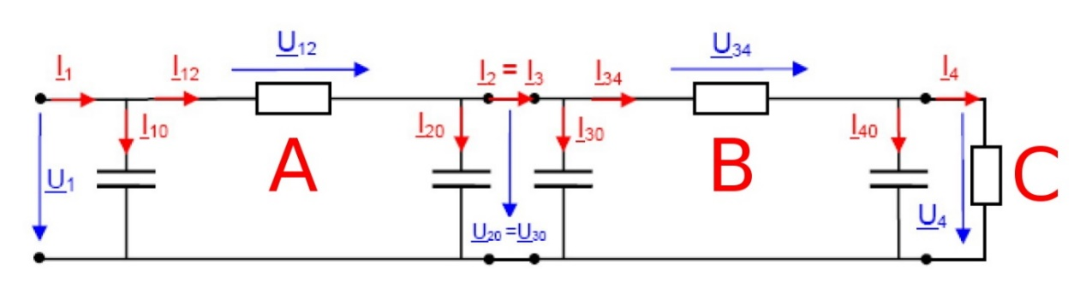
 | A=Line 1 | B=Line 2 | C=Load
Figure 3: Series connection of two lines
To trace the circuit's output parameters (load's star voltage U₄ and current I₄) back to its input parameters U₁ and I₁ , we proceed in two steps:
Half the working capacitance of line 2 is connected in parallel with the load. The current I₄₀ must be added to the load current to obtain the amperage I₃₄ through the line. This makes it possible to determine the voltage drop U₃₄ along line 2 and the voltage U₂₀ = U₃₀ at the point connecting both lines. Once this voltage is known, it becomes possible to derive the current I₃₀ flowing via half the working capacitance of line 2 (at the start). Both amperages together result in the value I₃ through the line. In the next step, the current I₂₀ flowing via half the working capacitance of line 1 (at the end) can be determined. As in the case of line 2, we obtain the current I₁₂ through line 1, the voltage drop U₁₂ along line 1, and the voltage U₁ at the start of the line. After that, it is possible to calculate the current I₁₀ flowing via half the working capacitance at the start of line 1. Together with the current I₁₂, this results in the total current I₁ consumed by the system.
As a rough approximation, a series connection of two lines can also be modelled by adding together the individual values of the elements, i.e. R = R₁ + R₂, L = L₁ + L₂ and C_{B} = C_{B1} + C_{B2}. The two lines can then be considered as a single, longer line.

Parallel connection
In this case, two or more lines are connected in parallel to enable a transmission of higher powers. Forming a basis for developing mesh networks, this kind of circuit is characterized by equal voltage drops across all lines. In practice, this means that the line of the lowest impedance conducts the highest amperage. Only in the case of two lines with identical ratings and lengths is the total current divided into equal halves.
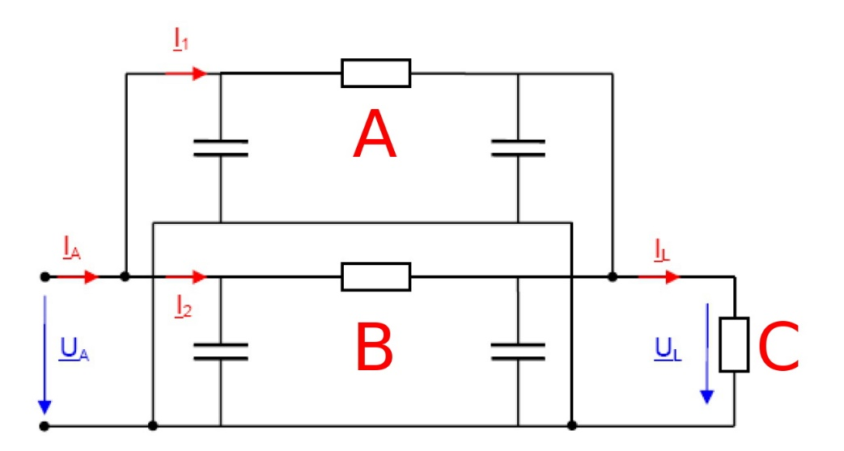
 | A=Line 1 | B=Line 2 | C=Load

Figure4: Parallel connection of two lines
A parallel connection can be represented simply by an equivalent impedance because no new nodes arise between the two lines. The two line impedances Z₁ and Z₂ form the equivalent impedance Z = R + j X, where:
Z = (Z₁ * Z₂) / (Z₁ + Z₂), whose resolution results in:
R = [R₁R₂ (R₁ + R₂) + R₁X₂² + R₂X₁²] / [(R₁ + R₂)² +( X₁ + X₂)²] and
X = [X₁X₂ (X₁ + X₂) + R₁² X₂ + R₂² X₁] / [(R₁ + R₂)² + (X₁ + X₂)²]
A phasor diagram need not be specified for this circuit because its conditions are identical to those shown in Figure 2.3, except that the parameters have changed. Two lines of equal lengths and ratings connected in parallel each conduct half the load current.

Series Connection
Procedure:
The experiments are performed with a supply voltage of 400 to 420 V (line-to-line voltage). Various combinations of differently long lines are studied here.
Two multi-meters and one analog-digital multimeter can be used to measure the relevant parameters comprising voltage, current as well as active and reactive power at different points of the circuit. The load is formed by a parallel connection of an inductance and a resistive load. Set the inductance to 2 H and the resistance to about 200 Ω before turning on the power. This prevents occurrence of an excessively high voltage at the end of the two lines due to the Ferranti effect.
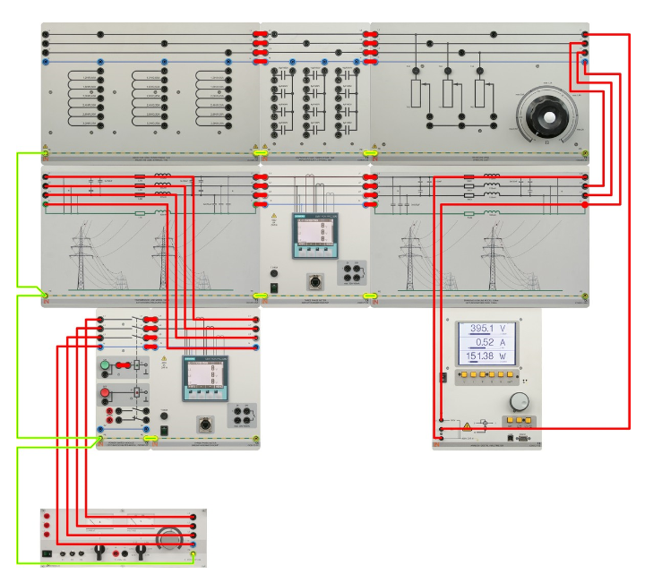
- Set up the circuit as illustrated next.
- Adjust the voltage at the beginning of line 1 to 242 V (420 V / √3) and readjust the resistance to achieve a load current of exactly 1 A.
Observations and Calculations:
Measured the variables listed below
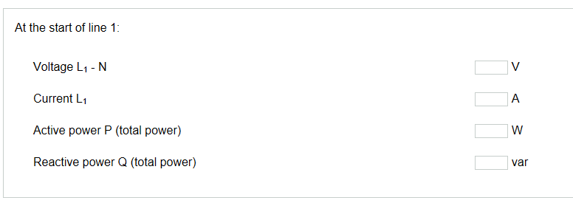
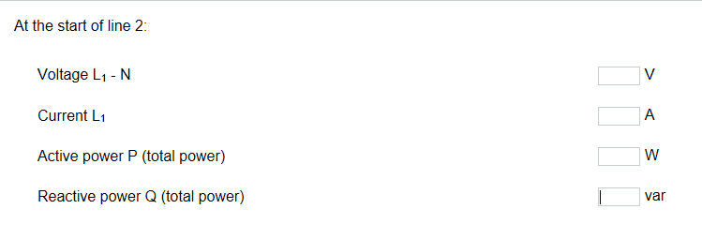
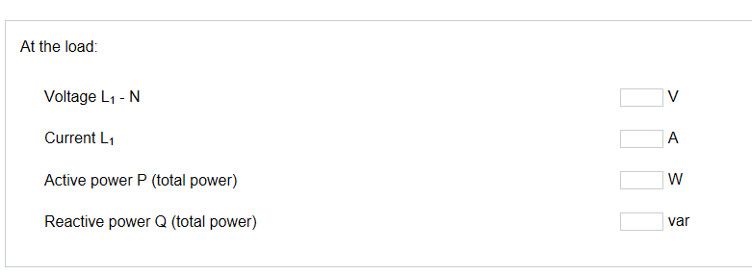

Parallel Connection
- Set up the circuit as illustrated next.
Two lines connected in parallel exhibit a lower voltage drop, so that a lower supply voltage is sufficient here. Furthermore, a parallel connection is capable of transmitting higher powers. Before turning the supply voltage on, set the inductance to 1.2 H and the resistance to about 200 Ω. This prevents occurrence of an excessively high voltage at the end of the two lines due to the Ferranti effect. First, we will operate two lines with a length of 150 km in parallel. The voltage at the beginning of the two lines is to be set to 230 V (400 V / √3), and the resistance readjusted to achieve a load current of exactly 1.6 A. Measure the parameters listed next.
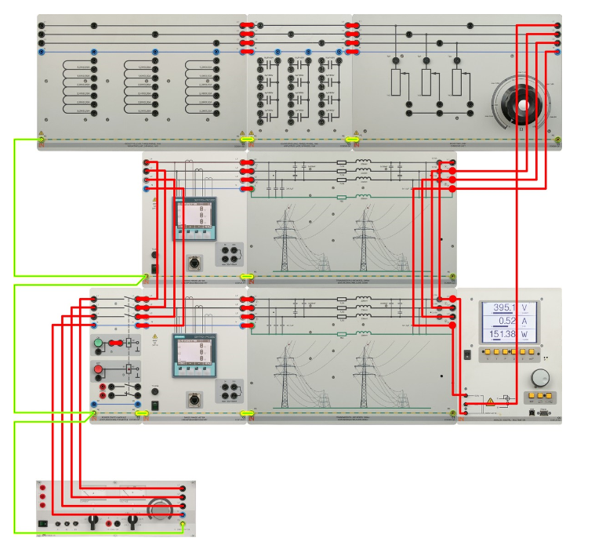
Observations and Calculations:
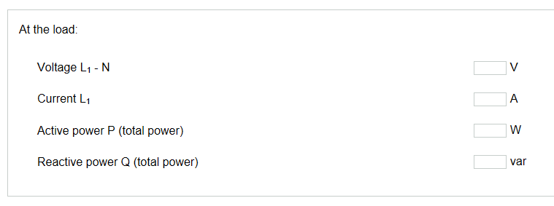

Experiment No: 8
Operation of a Line with Earth Fault Compensation
Single-phase representation is sufficient for considering a three-phase line exclusively in the symmetric mode. However, this single phase representation becomes inadequate on occurrence of an imbalance, especially if caused by a failure. Among the various mathematical calculation types available here, the method of symmetric components is now in widespread use.
It is based on the concept of breaking down the asymmetric three-phase system initially into individual, mutually independent systems. This procedure is known as analysis.
It results in two symmetric systems defined respectively as a positive sequence and a negative sequence. A third system, occurring only under certain conditions, is called the zero sequence.
This system is inapplicable, for instance, if the three-phase system purely consists of three phases without a return conductor. In practice, however, most three-phase systems contain a fourth conductor (earth wire, earth, cable jacket) as the return line.
The individual systems (component systems) thus formed are initially independent of each other. If an imbalance occurs in the form of a fault, its nature determines the resultant characteristics of the systems' joint circuitry.
The positive, negative and zero sequences are introduced next.
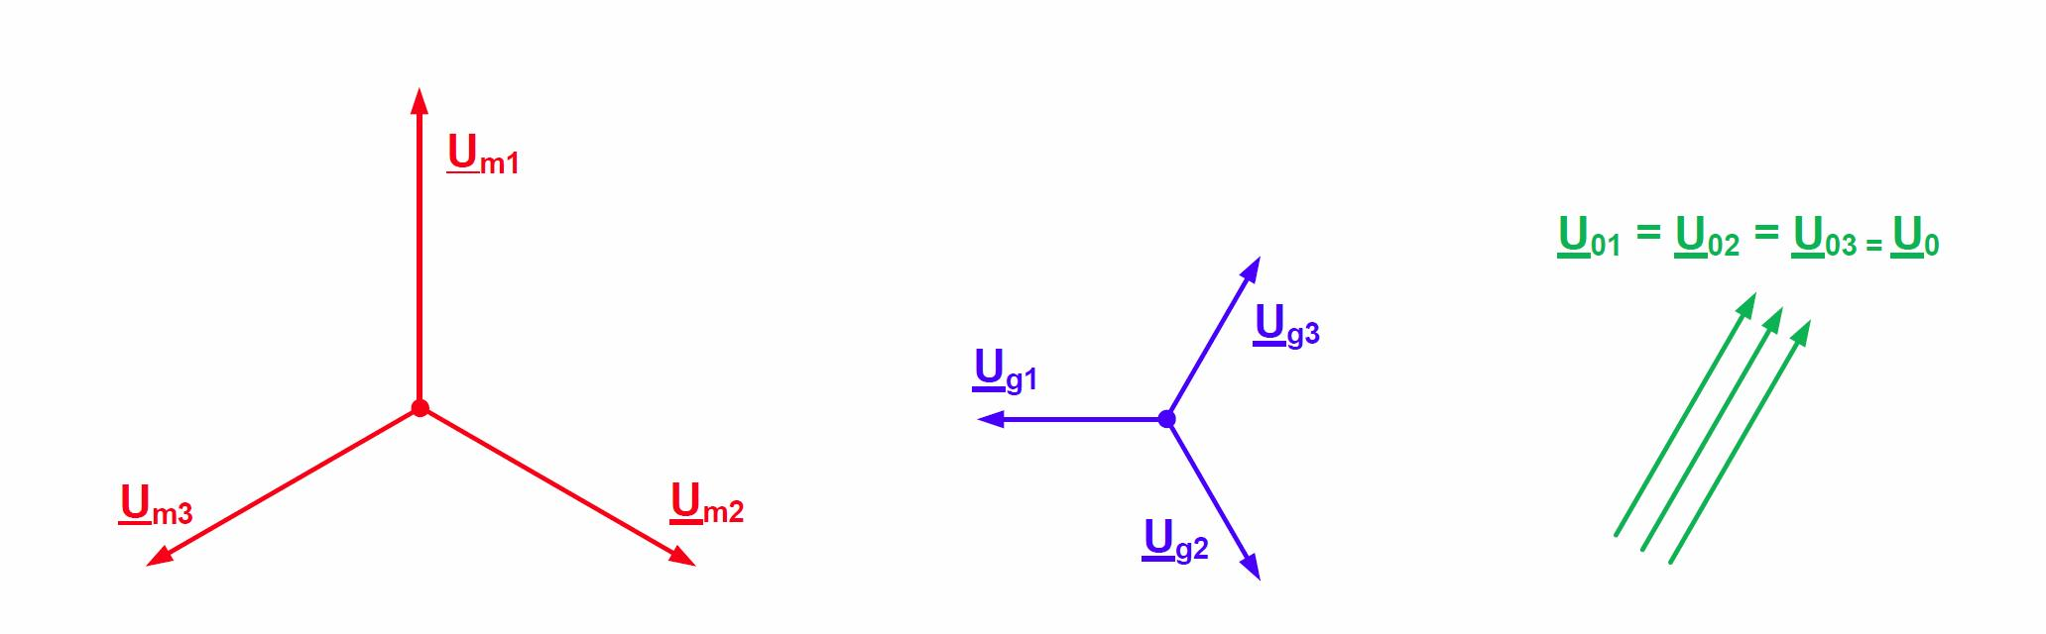
Figure1: Definition of positive, negative and zero sequences
Positive sequence: This sequence comprises three phasors equal in magnitude but phase-shifted mutually by 120° in the clockwise direction. We will identify each of the three phasors by an index m.
Negative sequence: This sequence comprises three phasors equal in magnitude but phase-shifted mutually by 120° in the counterclockwise direction. We will identify each of the three phasors by an index g.
Zero sequence: This sequence comprises three phasors equal in magnitude and in phase with each other. We will identify each of the three phasors by an index 0.
Conversely, one phasor each from a positive, negative and - if necessary - zero sequence can be used to compose an asymmetric three-phase system. Called synthesis, this process involves linear superposition.
Analysis and synthesis can be performed both graphically and mathematically. The graphic technique here serves merely to illustrate synthesis, preference otherwise being given to the computational method.
Illustrated below is the formation of an asymmetric voltage system's phasors U₁, U₂ und U₃ from the phasors of arbitrarily selected positive, negative and zero systems.
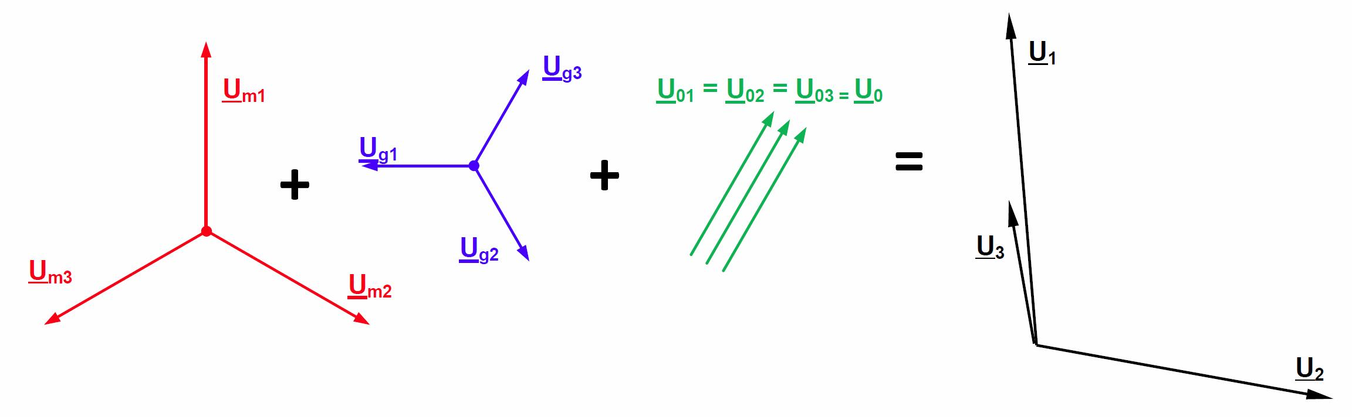
Figure 2: Synthesizing an asymmetric system from positive, negative and zero sequences
The following animation depicts the transformation in the positive, negative and zero sequences.
Figure 3.2b: Synthesizing an asymmetric system from positive, negative and zero sequences
The derivations further below are carried out with an arbitrary system of voltage phasors; the procedure applies similarly to systems comprising current phasors.
For a mathematical treatment, one defines a complex rotation operator a enabling a simplified description of a component system's individual phasors. The positive, negative and zero sequences are each represented only by a single phasor here; the other two phasors can be derived from the reference phasor with the help of the complex rotation operator.
The rotation operator a has the following value:
a = - 1/2 + 1/2 √3 j = e ^{j120°}
Multiplying a phasor by a therefore rotates the phasor by
+120° while leaving its length unchanged.
The relationships shown next apply furthermore to a.
a² = 1 / a = e ^{j240°}, a³ = 1 , a⁴ = a etc. Also: a² + a + 1 = 0
Consequently, a positive sequence's phasors can be represented as shown next.
U_{m1} = U_{m} , U_{m2} = a² * U_{m}, U_{m3} = a * U_{m}
The whole positive sequence is therefore now characterized by just phasor U_{m}.
Similar relationships apply to a negative sequence:
U_{g1} = U_{g} , U_{g2} = a * U_{g}, U_{g3} = a² * U_{g}
The whole negative system is therefore now characterized by U_{g}.
A zero sequence can anyhow be represented adequately by a single phasor (see Figure 3.1):
U₀₁ = U₀₂ = U₀₃ = U₀
Analysis and synthesis require transformation equations for breaking down an asymmetric system into components, or performing the reverse process.
The equations for synthesis are:
U₁ = U_{m} + U_{g} + U₀
U₂ = a² * U_{m} + a * U_{g} + U₀
U₃ = a * U_{m} + a² * U_{g} + U₀
The corresponding equations for analysis are derived from the equations above:
U_{m} = 1/3 (U₁ + a * U₂ + a² * U₃)
U_{g} = 1/3 (U₁ + a² * U₂ + a * U₃)
U₀ = 1/3 (U₁ + U₂ + U₃)
As mentioned earlier, the same relationships apply to asymmetric, three-phase current systems. Linking symmetric voltage components with symmetric current components gives rise to the concept of positive-sequence, negative-sequence and zero-sequence impedances:
Positive-sequence impedance Z_{m} = U_{m} / I_{m}
Negative-sequence impedance Z_{g} = U_{g} / I_{g}
Zero-sequence impedance Z₀ = U₀ / I₀
An electrical device's positive-sequence impedance Z_{m} is the quotient between the star voltage (line-to-earth voltage) and conductor current in the case of feeding by a symmetric, positive sequence. It corresponds to the longitudinal impedance already known for lines: Z = R + j X.
An electrical device's negative-sequence impedance Z_{g} is the quotient between the star voltage and conductor current in the case of feeding by a symmetric, negative sequence. A line's negative-sequence impedance is equal to its positive-sequence impedance, because the phase sequence does not influence the amperage.
An electrical device's zero-sequence impedance Z₀ is the quotient between the voltage and current if all three phases are fed by a single alternating voltage. The device's three phases are located in parallel and form the supply conductors, while a fourth conductor (neutral wire, earth, earth wire, cable jacket, cable reinforcement) serves as a common return line. This line accordingly conducts three times the zero current. Different currents therefore flow through the supply and return conductors. If this is considered during formulation of the mesh equation, the zero-sequence impedance is Z₀ = Z_{m} + 3 * Z_{E}, where Z_{E} = return conductor's impedance.
From the definition, it also follows that the zero-sequence impedance always refers to a device with a star connection. Devices with a delta connection cannot be assigned a zero-sequence impedance, due to the absence of a common return conductor.
There is no universally applicable relationship between an electrical device's zero-sequence, positive-sequence and negative-sequence impedances. A line's zero impedance, for instance, depends on the type of line (overhead line or underground cable), the line's structure (earth wire, cable jacket/reinforcement) and the conductivity of the local earth, which assumes part of the return conductor's function. Accordingly, the zero-sequence impedance is determined through measurements and estimates.
For each three-phase electrical device, it is therefore possible to specify a positive, a negative and a zero sequence. Naturally, this is also true for entire networks comprising a variety of equipment. A positive sequence's component network contains all related single-phases of equipment circuitry. The same applies to the component networks of the negative and zero sequences. The way in which these component networks are interconnected depends on the fault which has occurred.

Calculating unbalanced faults
For the sake of completeness and to permit quantitative comparisons between various types of short circuit, we will first briefly consider a three-pole (symmetric) short circuit. It can be determined by means of the following equation without a need for complex computation:
I _{sc 3-pole} = c * U_{N} / (√ 3 * Z _{total})
Explanation of some of the expressions used:
c = overshoot factor. Serving as a safety margin, this factor accounts for the possibility that the feed voltage might be higher than the rated voltage shortly before occurrence of a short circuit. A value of c = 1.1 is normally used for planning high-voltage networks. Because a constant mains voltage is present in the laboratory, an overshoot factor of c = 1 can formally be employed here. Because a single phase is considered in calculations, the feed voltage here comprises a star voltage. The (single-phase) voltage on occurrence of a short circuit is also known as the initial voltage E" = c * U_{N} / √3.
Z_{total} = total impedance of the short-circuited path. The short-circuit currents flowing through the three outer conductors are equal in magnitude, phase-shifted by 120°, and add up to a value of zero at the fault point. A return conductor (earth, earth wire, cable jacket) therefore need not be considered, and the short-circuited path's total impedance is the sum of the lines' and transformer's active and reactive resistances. By contrast, the supply network's internal resistance is usually negligible.
We will now consider the unbalanced fault types which might occur in a network with a solidly earthed neutral point. Other possible wirings for the neutral point are discussed later.
Demonstrated first is how to apply the method of symmetrical components when computing faulty networks. Rules for calculating short-circuits assume that the network is not under any load. The lines' working capacitances are of little influence and can be neglected.
As already mentioned, the type of short circuit occurring at the fault point serves as a basis for determining the interconnections of the component network following transformation.
The generator voltage remains symmetric even on an occurrence of unbalanced loads, the network's asymmetry being attributable solely to the respective fault. In component networks, the effective generator voltage therefore occurs only in the positive sequence, no feed signals being exhibited by the negative or zero sequence.

Single-pole short circuit
The single-pole short circuit is the most common unbalanced fault. Known as earth-fault, this type of short circuit is brought about by an electrical link between an outer conductor (L1) and earth.
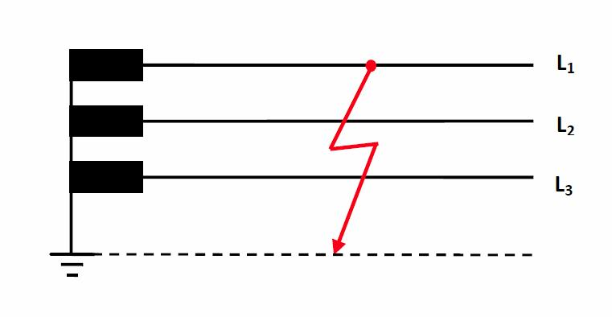
Figure 3: Single-pole short circuit (earth fault) on outer conductor L₁
The fault conditions listed next can be specified at the location of the short circuit.
1. I₂ = I₃ = 0 and 2. U₁ = 0
Transforming the fault conditions to the component level results in the following equations:
1. I_{m} = I_{g} = I₀ = 1/3 I₁ and 2. U_{m} + U_{g} + U₀ = U₁ = 0
Consequently, this fault type can only be associated with one kind of circuit for the component network: A series circuit.
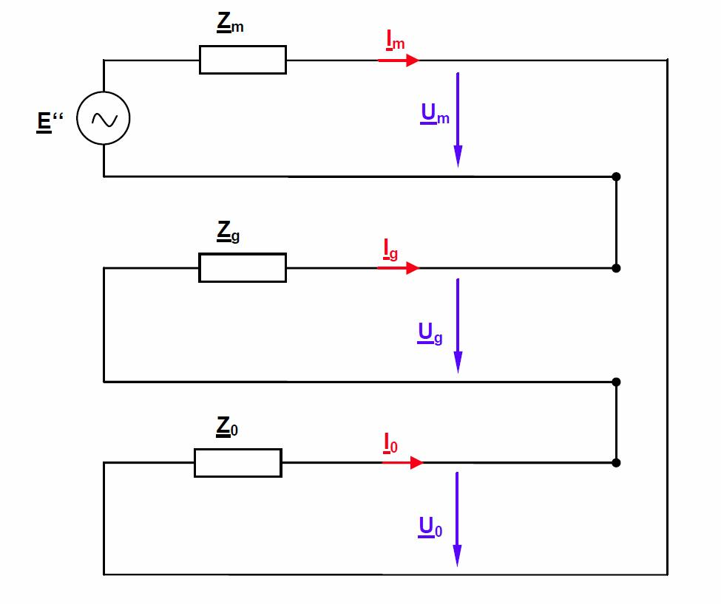
Figure 4: Equivalent component circuit in the case of a single-pole short circuit
Z_{m}, Z_{g} and Z₀ are the sums of the component impedances in the short-circuited path. E'' is the initial voltage. From the circuit above, the following relationships can be derived for the short-circuit current:
I₁ = I _{sc 1-pole} = 3 * I_{m} = 3 * E'' / (Z_{m} + Z_{g} + Z₀ )
The relationships shown next are obtained for the intact lines' voltages at the fault point:
U₂ = E'' * ((a² - 1) * + (a² - a) * Z_{g}) / (Z_{m} + Z_{g} + Z₀ )
U₃ = E'' * ((a - 1) * Z₀ + (a - a²) * Z_{g}) / (Z_{m} + Z_{g} + Z₀ )
The figure below provides a qualitative representation of the currents and voltages at the fault location. For the sake of simplicity, only the reactances are accounted for here.
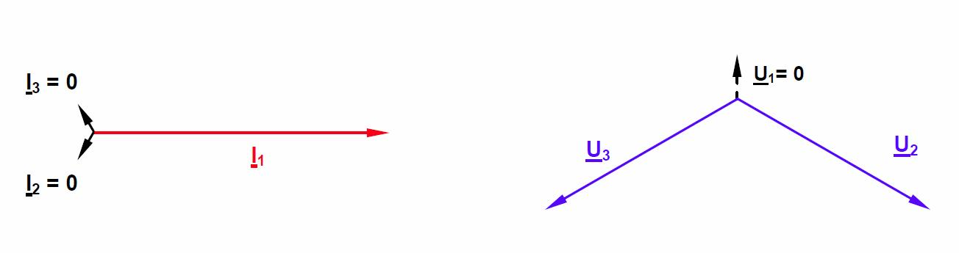
Figure 5: Diagrams for currents and voltages at the place of the single-pole short circuit
As previously mentioned, the derivation applies to a network with an earthed neutral point.
In the event of a failure, the voltages of the intact phases do not rise. Consequently, the conductor insulation need not be designed to withstand the full line-to-line voltage. At high voltages, the resultant economic benefits of saved insulation outweigh the disadvantage of having to immediately deactivate the affected line in view of the high fault current.

Two-pole short circuit with earth fault
Assumed here is an electrical link between the outer conductors L₂ and L₃ and a zero-impedance link to earth.
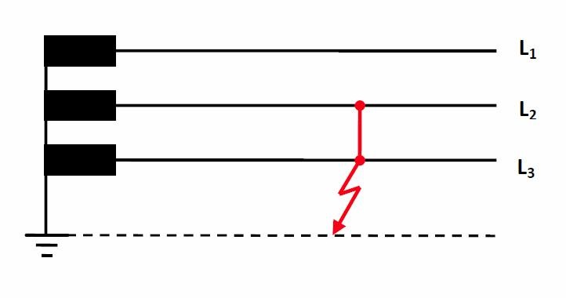
Figure 6: Two-pole short circuit on outer conductors L₂ and L₃ with earth fault
The current and voltage values at the fault point can be ascertained for this short-circuit type using the same procedure as that for the single-pole short circuit. Only the procedure's results are presented next.
The fault current is: I _{sc 2-pole} = j * 3 * E'' * Z_{g} / (Z_{m} * Z_{g} + Z_{m} * Z₀ + Z₀ * Z_{g})
It is composed (geometrically) of the two partial currents as described next.
I₂ = - j * √3 * E'' * ( Z₀ + (1 + a²) * Z_{g}) / (Z_{m} * Z_{g} + Z_{m} * Z₀ + Z₀ * Z_{g})
I₃ = + j * √3 * E'' * (Z₀ + (1 + a) * Z_{g}) / (Z_{m} * Z_{g} + Z_{m} * Z₀ + Z₀ * Z_{g})
The following relationship applies to the intact outer conductor's voltage at the fault location:
U₁ = 3 * E'' * Z₀ * Z_{g} / (Z_{m} * Z_{g} + Z_{m} * Z₀ + Z₀ * Z_{g})
The figure below provides a qualitative representation of the currents and voltages at the fault location. For the sake of simplicity, all active resistances in the network have been ignored.
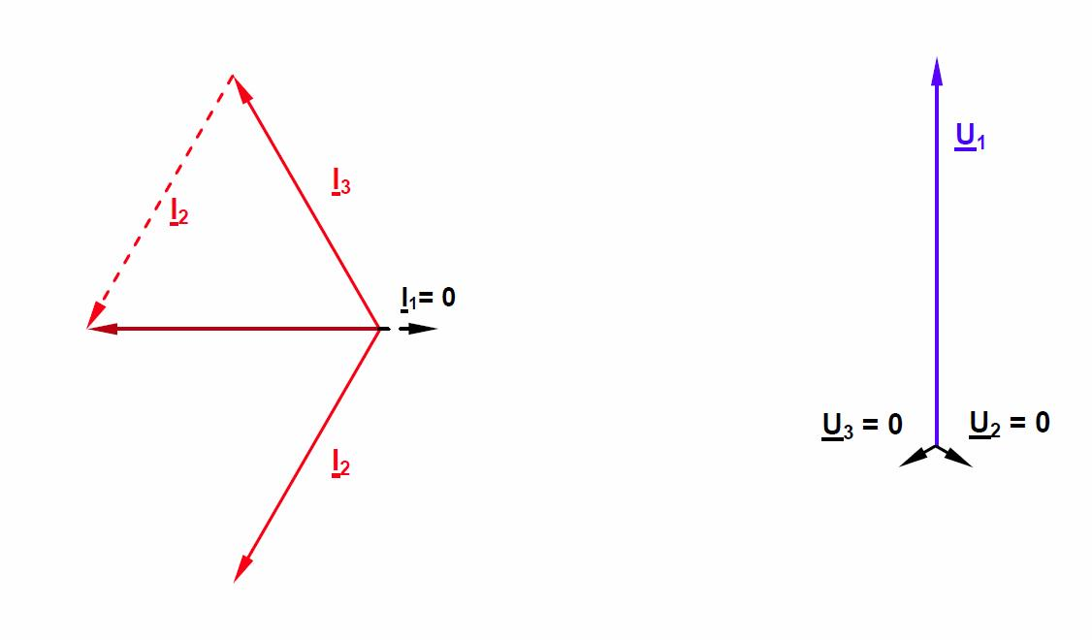
Figure 7: Phasor diagrams for currents and voltages at the fault location in the event of a two-pole short circuit with earth fault

Two-pole short circuit without earth fault
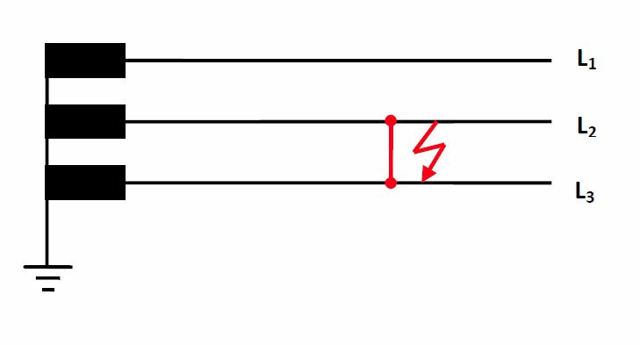
Figure 8: Two-pole short circuit on outer conductors L₂ and L₃ without earth fault
The calculation for this fault type is simplified due to the absence of a return line via earth, and consequential absence of a zero sequence. The following relationship applies to the currents of the affected outer conductors:
I _{sc 2-pole} = I₂ = - I₃ = - j √3 E'' / (Z_{m} + Z_{g})
In the case of transmission lines, Z_{m} = Z_{g}. Consequently, the value of a two-pole short circuit current without earth fault is I _{sc 2-pole} = √3 * E'' / (2 *Z_{m}) in both the affected conductors.
Because the zero sequence does not occur in the last equation, the amperage here can be compared easily with that of the three-pole short-circuit:
I _{sc 2-pole} / I _{sc 3-pole} = 1/2 * √3 ≈ 0.87.
The following relationships apply to the line-to-earth voltages of the three outer conductors at the fault location:
U₁ = 2 * E'' * Z_{g} / (Z_{m} + Z_{g})
U₂ = U₃ = - E'' * Z_{g} / (Z_{m} + Z_{g})
Provided below is a qualitative representation of the currents and voltages at the fault location. For the sake of simplicity, all active resistances in the network are again ignored.
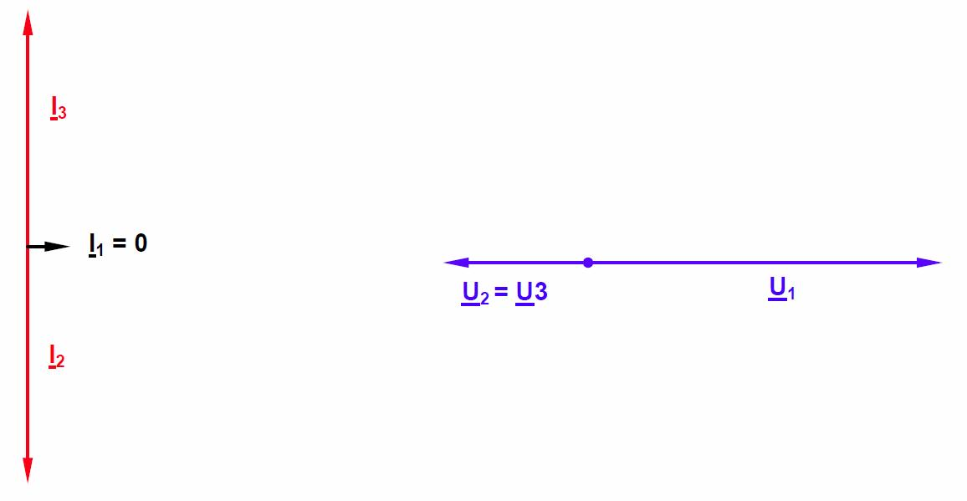
Figure 9: Phasor diagrams for currents and voltages at the fault location in the event of a two-pole short circuit without earth fault
The relationships shown above were derived for a network with an earthed neutral point. However, other possibilities of neutral-point wiring described next are also available in dependence on the voltage level.

Network with isolated neutral point or earth fault compensation
In addition to solid neutral point earthing used for most extra-high voltage networks, it is also possible to leave the neutral point in the disconnected, i.e. isolated state. The advantage of this is a lower fault current in the event of a single-pole fault, termed earth fault here. The current is produced exclusively by the line-to-earth capacitances.
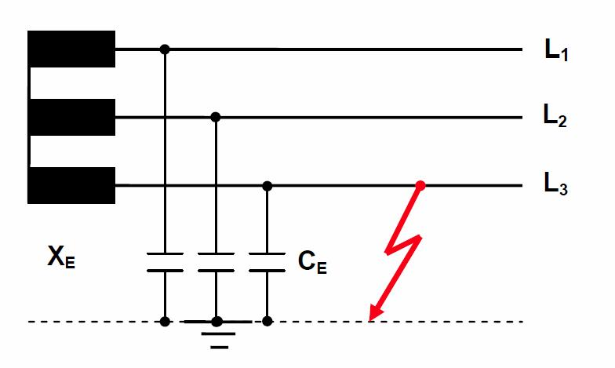
Figure 10: Network with isolated neutral point and earth fault on conductor L₃
In this case, the resultant earth fault current is: I_{E} = jω C_{E} * (U₁₃ + U₂₃).
If the two line-to-line voltages are assumed to have the rated level, then the value of the earth fault current is: I_{E} = √ 3 * U_{N} * ωC_{E}.
In addition to this purely capacitive component, the earth fault current also contains a small active component due to the line resistances and any arc resistance present at the fault location. The advantage of this neutral-point treatment is a low fault current; the disadvantage is a voltage rise occurring in the intact phases. As indicated in Figure 3.10, the voltage rises from a value of U_{N} / √3 to the concatenated value U_{N} with respect to earth. Given appropriate isolation, networks with an isolated neutral point can be operated for a while after occurrence of a single-pole fault, until the affected consumers have been appropriately switched over to alternative supply channels.
On the other hand, it is often very difficult to detect earth faults due to the low fault currents, and the voltage rise in the intact phases poses a risk of further faults elsewhere in the network (known as double earth fault). Consequently, this kind of neutral-point treatment is restricted to a few special cases such as small-scale, medium-voltage networks and local-service networks at power plants.
The fault current occurring in the case of an isolated neutral point is almost exclusively of a capacitive nature. Consequently, it can be compensated (quenched) by a parallel-connected inductance inside the fault-current circuit. An earth-fault quenching coil, also known as Petersen coil after its inventor, operates on this principle. Neutral-point treatment is performed via a coil which must be matched to the network's line-to-earth capacitances. Because these capacitances' total value changes during connection and disconnection, the quenching coil's inductance must also be variable. Petersen coils are therefore furnished with taps or a plunger.
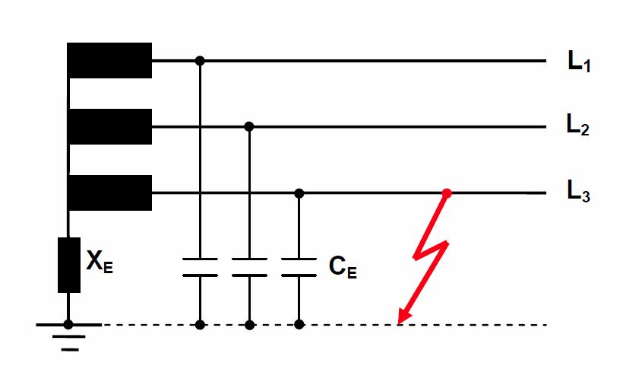
Figure 11: Compensated network with earth fault on conductor L₃
According to the method of symmetric components, the earth-fault quenching coil's inductance in the event of resonance is:
X_{E} = 1 / (3 ωC_{E} )
The earth-fault current's active component, which cannot be compensated in this process, amounts to about 5% - 10% of the fault current and is known as residual earth-fault current.
If an electric arc is present at the fault location, the arc is extinguished automatically through cooling if the residual current is sufficiently low. This is the chief technical and economic benefit of the Petersen coil in transmission networks purely comprising overhead lines and / or a low proportion of underground cables. On occurrence of a fault in networks purely comprising underground cables, self-extinguishing is not possible; instead the fault current is only limited.
In networks transmitting extra-high and high voltages, the residual earth-fault current would usually be too high to allow self-extinguishing. Consequently, earth-fault compensation is used primarily in medium-voltage networks, and only occasionally in high-voltage networks operating at up to 110 kV.
Because of the high currents occurring in the event of a failure, the line model is operated at a rated voltage of 110 V during the experiments. At this rated voltage, too, the model realistically reproduces the values R, L and C_{B}. The measurements are carried out at a line length of 300 km. Two multi-meters can be used to simultaneously measure all voltages and currents at both line ends.
Increase the voltage of the feeding transformer at the start of the line in small increments to the specified value, making sure that the maximum permissible amperage (2.5 A) is not exceeded anywhere. All short-circuit tests should be carried out expeditiously at the specified supply voltage. The current should be switched off as soon as the desired readings have been obtained.

Measurement of zero-sequence impedance
Procedure:
The line's zero-sequence impedance must be known in order to analyze the line's response to asymmetric short circuits too. This is achieved by means of the test circuit shown below. The negative-sequence impedance need not be determined separately, being equal to the positive-sequence impedance in the case of static systems such as transmission lines. We will only conduct a measurement at a line length of 300 km.
All three phases of the line are connected to a single alternating voltage, the earth or earth wire serving as the return conductor. This is neutral conductor N in the case of the line model. The zero sequence impedance is the ratio between the applied voltage and measured current. Note that the zero current I₀ flowing through each of the conductors increases by a multiple of three (3 * I₀) in the return conductor.
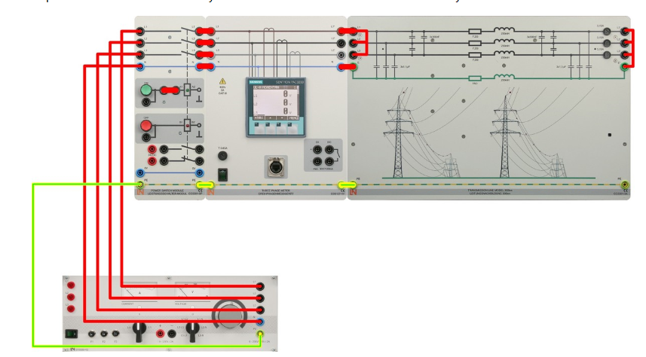
Conduct the measurement at a voltage of 110 V.
Current I₀ in an outer conductor at the line's end | 0.42 A
Consumed active power 3 * P₀ | 28.2 W
Consequently, the value of the zero-sequence impedance Z₀ = U₀ / I₀ = 262 Ω.
The power measurement can be used to determine the active component of Z_{0:}

The active power consumed by the whole line was measured. Accordingly, P₀ = 9.4 W are distributed proportionally among each of the conductors and the return conductor. R₀ is determined from the equation R₀ = P₀ / I₀² = 53.3 Ω, and the reactive component X = √(Z₀² - R₀²)= 256.5 Ω.
The result is to be compared with a calculated value:
According to section "Theoretical fundamentals", Z₀ = Z_{m} + 3 * Z_{E}. If Z_{m} = (7.2 + j 72.3) Ω and
Z_{E} = (15 + j 62.8) Ω are used, then Z₀ = (52.5 + j 260.7) Ω .

Symmetric (3-pole) short circuit
For comparison, a three-pole short circuit is analyzed first.
Set up the circuit as illustrated below; after the right-hand multimeter, connect the three outer conductors to each other and to the neutral conductor.
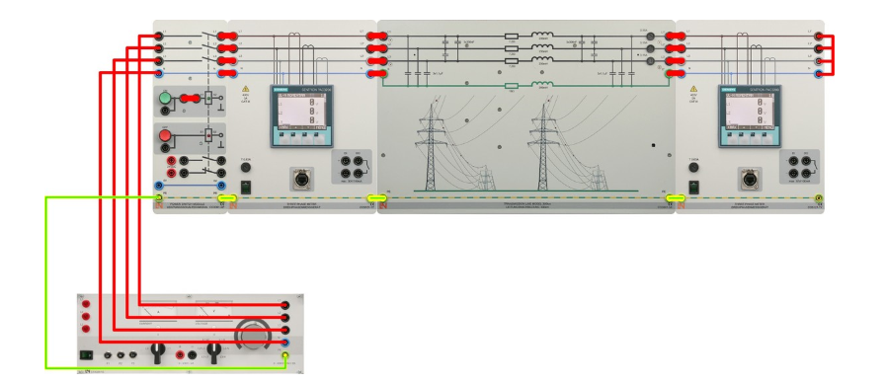

Observations and Calculations:
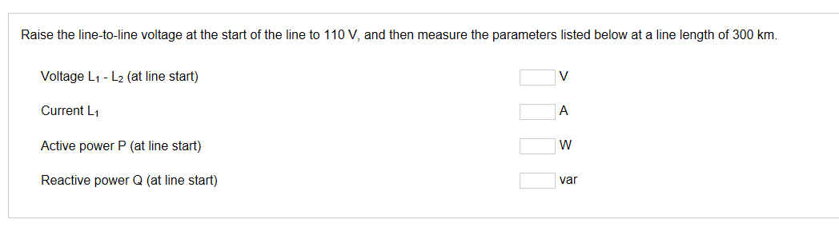

Asymmetric short circuits
To determine currents and voltages in the case of unbalanced faults, the circuit only needs to be modified slightly. The same fault types as those specified in the theoretical part are simulated here.

Single-pole short circuit (earth fault)
After the second multimeter, connect outer conductor L₁ to the neutral conductor.
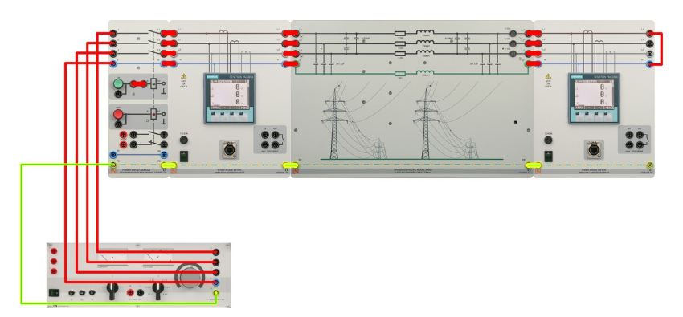
Observations and Calculations:
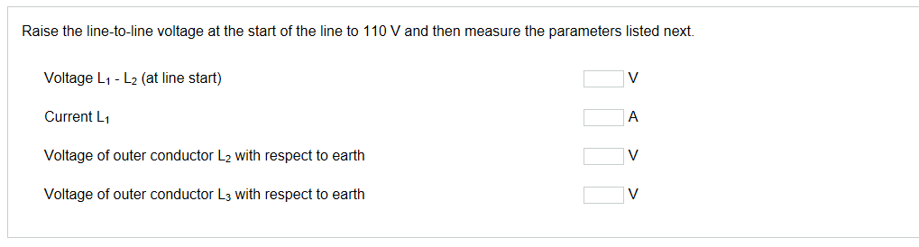

Two-pole short circuit with earth fault
After the right-hand multimeter, connect outer conductors L₂ and L3 together and to the neutral conductor. Use an additional ammeter to measure the sum I _{sc 2-pole} of the two currents.

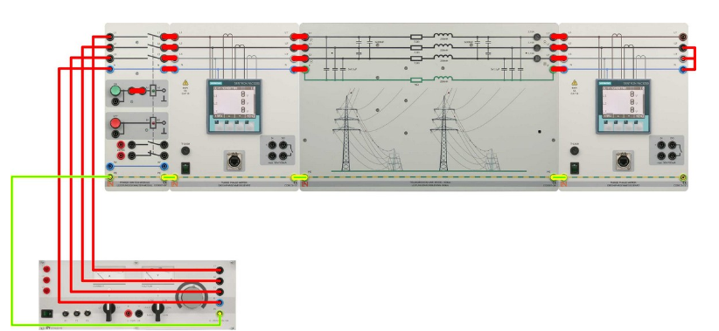
Observations and Calculations:
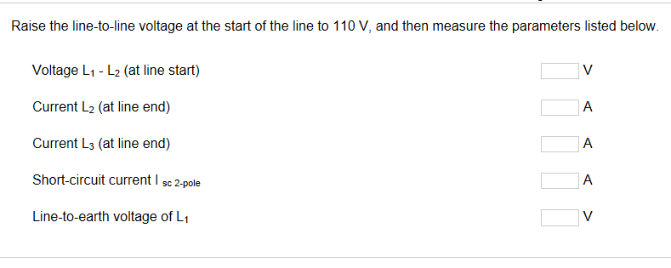

Experiment No: 9
Investigation of a Three Phase Underground Cable
Cables used for high-voltage power transmission can belong to any one of the essential design categories comprising ground cable, oil cable, gas-pressure cable or plastic cable.
Gas-insulated conduits and cables which use the physical effect of superconductivity and are still in the development stage will not be further discussed here.
Common to all cable types is a relatively complex structure comprising several layers, the conductor potential needing to be lowered as far as ground potential in an extremely confined space. In this context, a formation of cavities in the insulation poses a great danger. This is caused by expansion or contraction of the insulating material under varying loads and, consequently, temperatures. Cavities have a lower permittivity than the surrounding material, thus raising the local field strength to result in partial discharges and, inevitably, cable damage.
A copper or aluminum conductor is surrounded by wire insulation. This arrangement of conductor and insulator is referred to as a wire in cable technology. As with overhead lines, this arrangement includes no neutral conductor, i.e. a high-voltage cable always comprises three wires.
In the case of a three-conductor cable, the three wires are surrounded by a common, grounded shield; in the case of a single-conductor cable, each wire is individually protected by a grounded shield. For applications requiring large cross-sections, single-wire variants are always used due to their advantages in terms of installation and lower transport weight.
In the case of ground cables, the insulating layer comprises oil-soaked paper. Applied between this layer and the conductor is an inner conductive layer which ensures homogeneity of the electric field at the conductor's surface. The wire insulation, too, is furnished with an outer conductive layer to homogenize the field. For protection against moisture and mechanical damage, the cable must furthermore be provided with an aluminium or lead sheath.
Designed like ground cables, oil cables in each case comprise a hollow conductor through which thin oil is pumped under pressure. This prevents a formation of cavities by alternating thermal stresses. Due to their perennial risk of contaminating ground water, ground and oil cables are now installed only in exceptional cases.
Gas-pressure cables pose no such risk, their design comprising three single-wire ground cables installed jointly in a steel conduit. This pressure-resistant conduit is filled with nitrogen maintained at about 15 bar. A distinction is made here between external and internal gas-pressure cables. In the case of external gas-pressure cables, the nitrogen atmosphere is located between the three single-wire cables and the gas tube. Gas pressure acts on the wires from outside, thus preventing a formation of cavities. In the case of internal gas-pressure cables, the nitrogen gas is located inside each wire, thereby also serving as an insulator and preventing a formation of cavities in this manner.
A plastic cable's insulation comprises polyvinyl chloride (PVC) in low-voltage technologies, and cross-linked polyethylene (PEX or XLPE) in applications involving medium or higher voltages. Possessing excellent dielectric and thermal properties, this plastic is therefore used even for the highest possible voltage levels now. In high-voltage applications, this type of cable is also furnished with an inner and an outer conductive layer to homogenize the field pattern. An outer shield comprising a copper braid and plastic sheath is usually applied as additional protection.
PEX cables pose no risk to ground water, nor do they absorb any water themselves. They are chemically neutral and resistant, have a low weight and can be laid with bending radii tighter than those afforded by other sorts of cable. They are the favoured cable type nowadays.
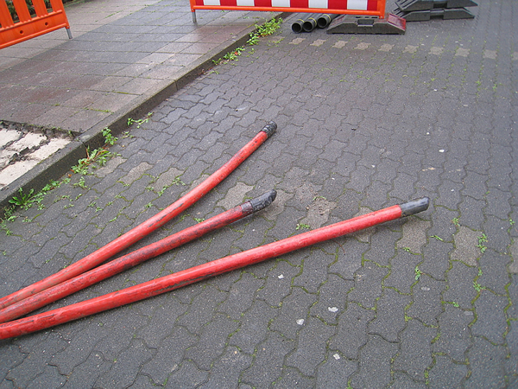
110kV cables being installed in the city of Karlsruhe
Due to their smaller conductor spacing and their insulation's higher dielectric constant compared with air, cables generally have a much greater capacitance than overhead lines. As a result, a cable also conducts a much higher charging current than an overhead line, even in the no-load state. Increasing in proportion to cable length, the charging current ultimately reaches the value of the continuous current, which the cable simply cannot handle for thermal reasons. At this critical length, the cable can no longer fulfil its intended purpose of transmitting active power.
Charging capacity can be compensated by parallel connections of charge-current coils which have to be installed in multiple instances as the cable link becomes longer. Such coils are large and expensive, and completely unfeasible for undersea cables, for instance. The only remedy here is a use of DC links which basically dispense with the problem of the charging current.
Similarly to the case of overhead lines, the equivalent circuit diagram shown below is sufficient for a consideration of a short cable route in the steady operating state. Because a single-conductor cable's wire is provided with a grounded shield in each case, however, there are no capacitances between phases, as opposed to overhead lines.
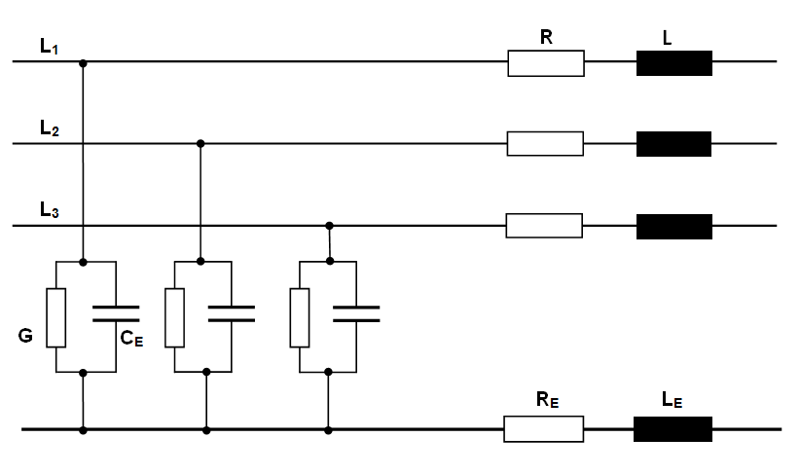
Figure 1: Three-phase equivalent circuit diagram of a high-voltage cable (single-conductor)
Treated first of all are symmetric operating modes involving equal voltages and currents in all three phases. A return conductor is not needed here, because the three-phase currents add up to zero in the case of balanced loads.
The equivalent circuit diagram is accordingly simplified as follows:
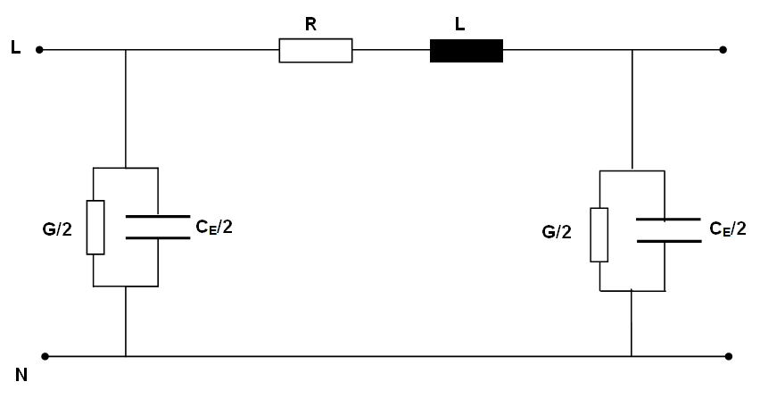
Figure 2: Single-phase equivalent circuit diagram of a high-voltage cable
As with overhead lines, the dissipation losses (represented by the conductance G) can be neglected. This is always permissible in the case of modern plastic cables with high-grade insulation.
The longitudinal resistance R is determined by the conductor material and its cross-section.
Only aluminium and copper come into question as materials. Because the extra price of copper does not significantly impact a cable's total cost, copper is usually selected because of its lower resistivity.
In practical operations, the resistance has a much higher value than the one calculated from resistivity and conductor cross-section. This has three reasons: Firstly, the cable is operated at a much higher temperature than the ambient temperature. Depending on the surrounding soil's thermal conductivity, the manufacturer approves operating temperatures of up to 90°C. Secondly, the skin effect results in higher current-heat losses. At large cable cross-sections from about 1000 mm², subdivision into individual conductor segments is therefore often performed. Thirdly, in the case of alternating currents, the induction effect always gives rise to currents in the shield as well. Depending on the type of shield grounding (at one line end, at both line ends, or with cross-bonding when the wire shields are cross-linked at the cable sleeves in the line path), this results in additional losses assigned mathematically to the conductor resistance.
The permissible continuous current also depends on the maximum possible conductor temperature. It is furthermore influenced by the installation method, it being possible to lay the three wires side-by-side in a single plane, or in a triangular arrangement in the cable trench. Though side-by-side installation is more efficient in terms of heat dissipation, it requires more space in the cable trench. Finally, also of importance to load capacity is whether one or more systems are installed in the trench. In any case, it is necessary to ensure good thermal conductivity of the embedment, and avoid formation of cavities.
A cable's inductance L and, consequently, its reactance X are principally lower than those of an overhead line with a similar transmission power, due to the smaller conductor spacings. Installation type plays an additional role in the case of single-conductor cables. In the case of a triangular arrangement, the wires are located closer together, thus resulting in slightly lower inductances compared with individual wires arranged side-by-side in a single plane.
The working capacitance C_{B} is composed of the mutual line capacitances (C_{L}) and the line-to-earth capacitances (C_{E}). As mentioned earlier, single-conductor cables do not exhibit the component C_{L} because of the shielding, so that the following applies here: C_{B} = C_{E}. This permits easy calculation of the individual capacitances according to the known relationships for a cylindrical capacitor. Of great importance here is the insulating material's relative permittivity ε_{r}, which lies in the range from 2.3 to 4.5, and equals 2.4 in the case of PEX, for instance. Also as mentioned earlier, this results basically in higher capacitance values for underground/undersea cables compared to overhead lines.
Like overhead lines, cables too can be considered as having low losses, i.e. their longitudinal resistance R is much lower than their reactance X, and their conductivity G is small compared to the conductance of their capacitance.
The equivalent circuit diagram shown next therefore suffices for a basic consideration:
Figure 3: Single-phase equivalent circuit diagram (simplified) of a cable
Needed in the case of unbalanced loads (such as one- or two-pole short-circuits) are the positive, negative and zero sequences according to the method of symmetrical components. The positive and negative sequences' impedances are identical in the case of underground/undersea cables as well as overhead lines.
The zero impedance is influenced decisively by the shielding's nature and grounding, as well as soil conditions. Even if these details are known in addition to the cable data, the precise values can only be determined through measurement of the installed cables.
However, the zero sequence's resistance and reactance are always higher than the positive sequence's corresponding values. Standard values lie in the range from a multiple of two to ten. In the case of a cable model, the common return conductor's values R_{E} and L_{E} must be selected appropriately to fulfil the above-mentioned condition for zero impedance in accordance with the equation R₀ = R + 3·R_{E} or X₀ = X + 3·X_{E}.
In the case of a cable too, the characteristic impedance calculated as Z_{W} = √(L / C_{B}) is of significance to operational behaviour. Due to the much higher capacitances here, however, this impedance is always smaller than that of an overhead line.
The general method of terminating a line by means of a resistive load equal to the line's characteristic impedance is known as matching. However, this is not possible for cables because the lower characteristic impedances here require correspondingly low load resistances. The resultant amperage would be far higher than the cable's permissible operating current. Unlike overhead lines, cables can therefore only be operated below natural level. This makes them capacitive at all times, i.e. the capacitive reactive power they produce exceeds the inductive reactive power they consume.
Like in the experiments on overhead line models, the cases involving no-load, normal operation under resistive load and symmetric short circuit can be lucidly represented by means of the following circuit diagram:
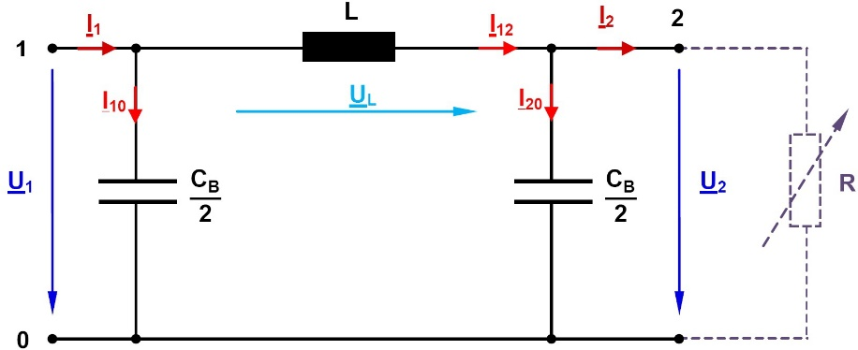 | R=∞ -> no-load  R=Z_{w} -> Matching  R=0 ->Short circuit
Figure 4: Cable operation under various types of load
Computations as part of single-phase representation make use of star voltages, i.e. those occurring between a phase and the neutral point (by contrast, the voltage measured between any two outer conductors is termed line-to-line voltage (U_{Δ}) as in the case of overhead lines.
When considering a three-phase system again, the powers calculated as part of single-phase representation must now be multiplied by a factor of 3 to obtain the total power (We will employ the following designations here (complex variables are underlined):
U₁, U₂ : Voltages at the cable's start and end (star voltages)
U_{L} : Voltage drop across the cable
I₁, I₂ : Currents at the cable's start and end
I₁₀, I₂₀ : Current through the shunt arm at the cable's start and end
I₁₂ : Current through the cable's longitudinal branch
In the no-load state, the terminating resistor R at the cable's end is infinitely large, so that the current I₂ = 0.
The following current/voltage phasor diagram represents the no-load situation:
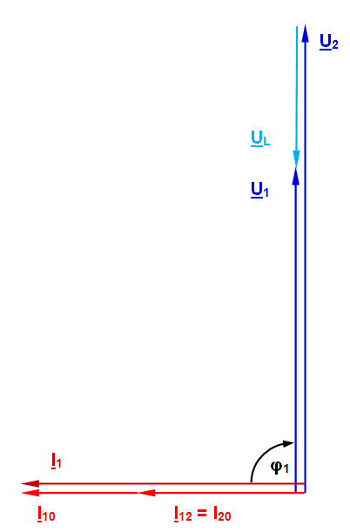
Figure 5: Cable's current/voltage phasor diagram in the no-load state
In this operating state, the voltage at the cable's end is higher than that at the cable's start. Attributable to the working capacitance, this is known as the Ferranti effect.
The voltage at the cable's end rises disproportionately to the cable's length, and can reach dangerously high values. This operating state is therefore avoided wherever possible in practice.
The current flowing in the no-load state is termed charging current, the associated reactive power is termed charging power. As mentioned previously, cables have high working capacitances, the effects described earlier being much more significant here compared with overhead lines. In addition, the high charging capacity in the order of several Mvar per kilometre limits the cable route's permissible length. After that, the cable can no longer transmit any active power beyond the required charging power without causing an overload. Whereas an underground cable's charging power can be compensated by installing appropriately dimensioned charge-current coils along the line's route, undersea cables do not offer this possibility because of the notable dimensions of such facilities.
The phasor diagram below describes the situation involving a resistive load at the cable's end:
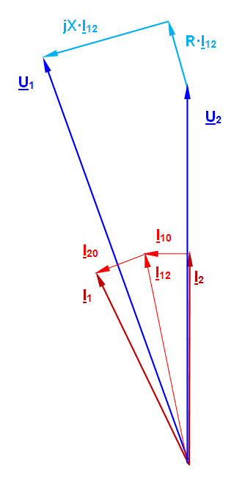
Figure 6: Cable's current/voltage phasor diagram given termination by means of a resistive load
The load current I₂ here is in phase with the voltage U₂. First, the load current must be added to the current I₂₀ divided by half the cable capacitance in order to obtain I₁₂ (the current through the cable's longitudinal branch). Once this parameter is known, both the voltage drops across the cable's active resistance and reactance can be determined. In this manner, one obtains the voltage U₁ at the line's start, the current I₁₀ through the other half of the cable capacitance, and finally the current I₁ at the line's start.
Illustrated next is the cable's behaviour given supply via a mixed, resistive-inductive load; the phasor diagrams are constructed as in Figure 5.6, so that no detailed explanation is needed again here.
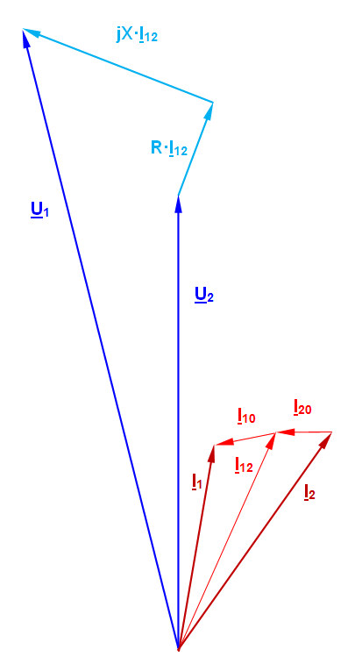
Figure 7: Cable's current/voltage phasor diagram given termination by means of a resistive/inductive load
Just like with overhead lines, a compensation capacitance can be used to improve a resistive-inductive load's power factor. As described in detail in "Investigating three-phase lines", compensation is usually not carried out to a power factor cos φ = 1, but only up to a value of 0.8 for economic reasons. The experiments here simulate both these cases of parallel compensation.
Series compensation is not needed due to the cable lengths which come into question here.
Occurrences of short circuits and ground faults, though less frequent than in the case of overhead lines because of the protected installation in soil, usually lead to destruction of the cable. Because repair here takes much longer compared with overhead lines, the potential economic damage caused by interrupting the power supply for large numbers of customers is correspondingly higher. Careful adjustment of the protective devices (relays) is therefore of particular importance.
Furthermore, the cable route must be protected against overload to prevent Joule effects from irreparably damaging the cable and drying the surrounding soil.
Cable routes and overhead lines have comparable transmission capacities if the same voltage levels are involved. At the high-voltage level of 110 kV, for instance, the transmission capacity is typically in the order of 100 MVA per system. This is sufficient to supply a city of about 100,000 inhabitants and the associated industrial zone.
If the transmission power needs to be doubled, for instance, it is not sufficient to simply double the conductor cross-section as in the case of an overhead line. Because of soil drying, excessive heating due to current heat losses must be avoided here. Because such losses are proportional to the square of the current, doubling the amperage entails quadrupling the conductor cross-section to maintain the losses at the same level.
Naturally, the transmission capacity also increases when higher voltages are used, especially because larger cross-sections are generally selected then too. As already mentioned, this also increases the transport weight of the cables / cable drums, thus necessitating shorter sections with numerous couplings and consequently, uneconomical solutions in many cases involving cable routes. High-power cables are therefore found only in markedly metropolitan areas with extremely high load densities.
Procedure:
The experiments here simulate no-load, various loads, and three-phase (symmetric) short-circuits with the two cable lengths of 12.5 km and 37.5 km. Two multimeters can be used to simultaneously measure all voltages and currents as well as the active, reactive and apparent powers at both line ends.
The feeding transformer's voltage at the cable's start is to be increased in small steps up to the specified value in each case. In this process, make sure that the permissible values of the voltage (110 V between two outer conductors) and current (briefly 2 A in the short-circuit tests) are not substantially exceeded anywhere.

No-load
Set up the circuit as illustrated below.
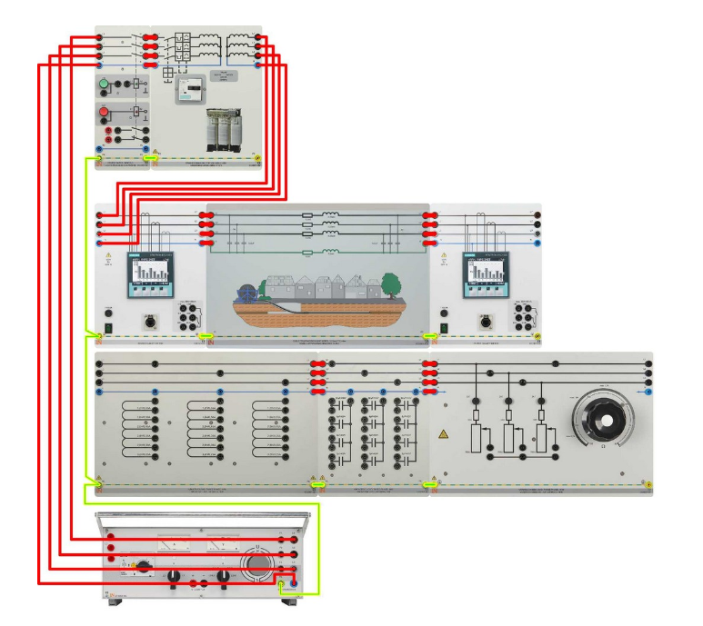
To study behaviour under no-load, the resistive load is completely disconnected. For both cable lengths, set the voltage to the nominal value (110 V) at the start of the cable model. The phase or outer conductors are designated L₁, L₂ and L₃, the neutral conductor N. Measure the variables indicated in the table; the powers always comprise three-phase values, i.e. total power levels.
Observations and Calculations:
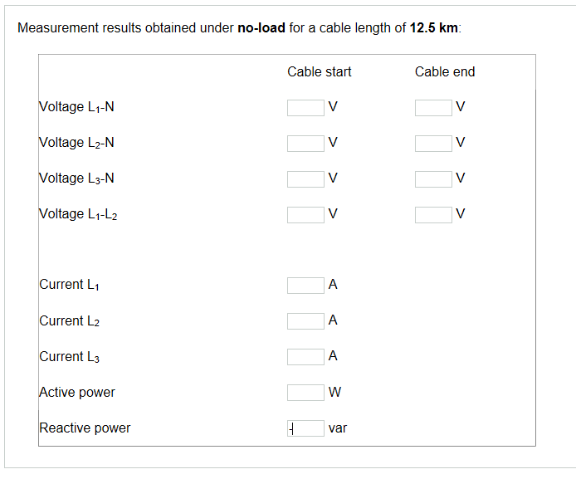
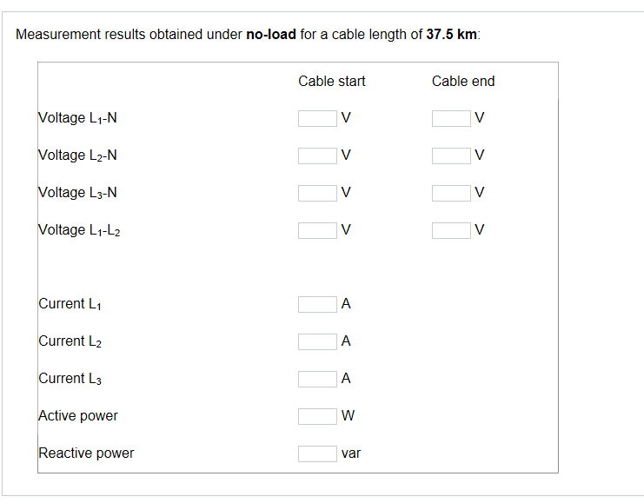
Matching
Set up the circuit as illustrated next.
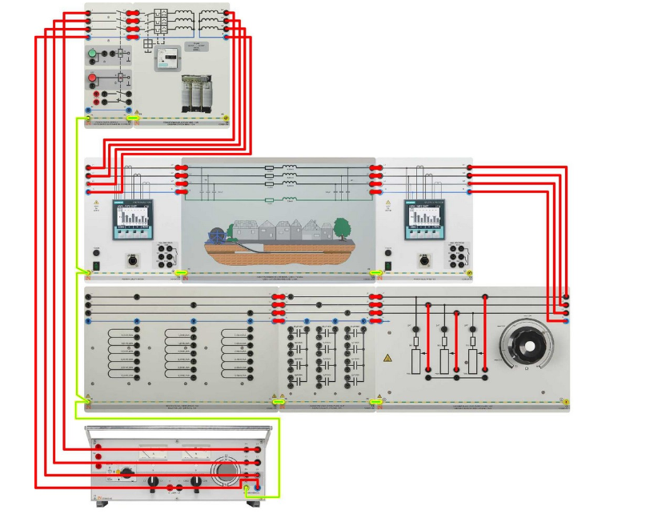
To study the response during matching, the resistive load is decreased from its maximum value until attainment of the power consumption levels specified in the table below. In the case of both line lengths, the nominal voltage of 110 V is to be set at the start of the cable and kept constant through readjustment whenever necessary.
Observations and Calculations
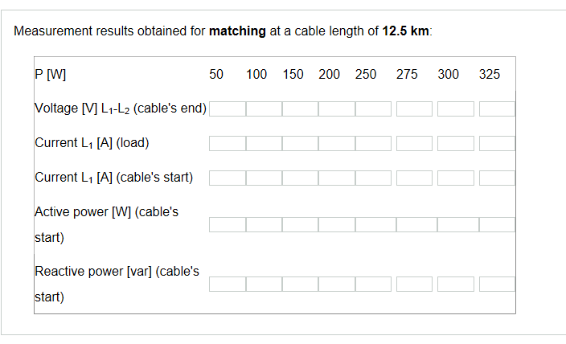
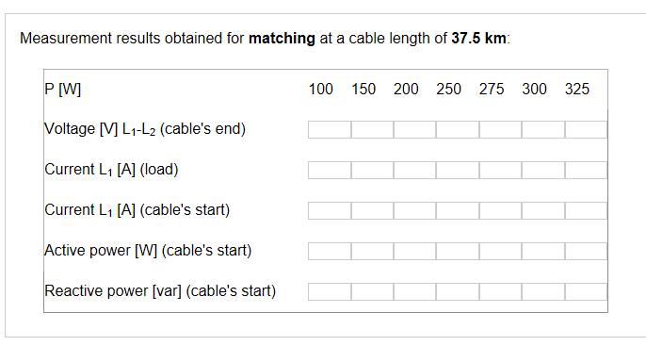

Experiment No: 10
Transmissions Lines Combining Overhead Lines and Cables
Set up the circuit as illustrated below.
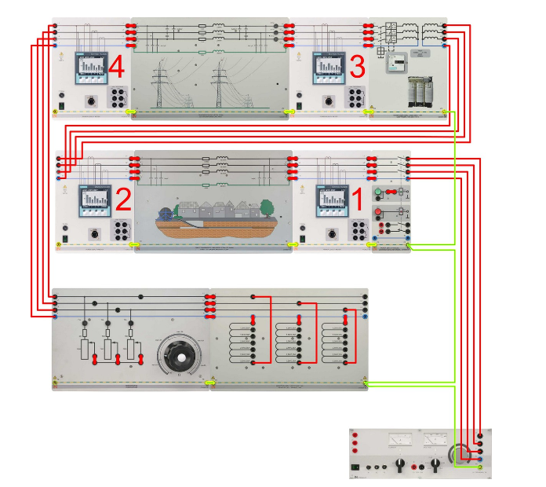
The overhead line model remains set to a length of 300 km, the cable model being set to 37.5 km. Set the adjustable three-phase supply to 110 V phase-to-phase voltage. The load here again comprises a resistor connected in parallel to a 3.2 H inductor, both forming part of a star circuit now. This results in comparable load conditions at the end of the transmission line in both experiments.
Change the value of the resistive load value until it consumes an active power of 200 W (total power of all three phases) and measure the variables listed next.

Observations and Calculations:
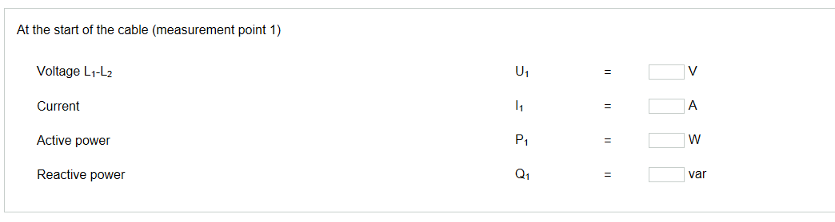
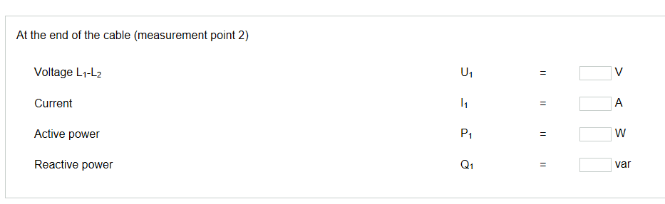
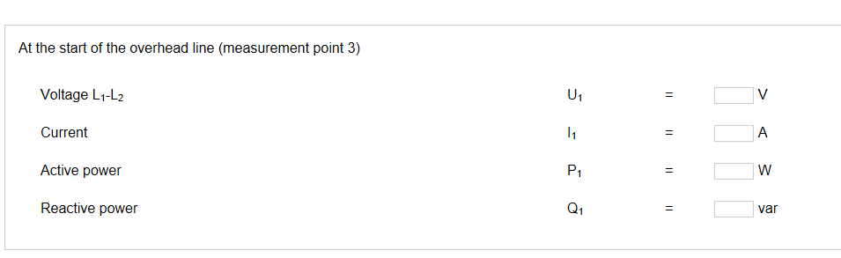
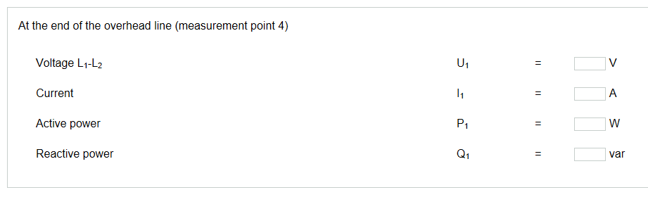

Experiment No: 11
Power Flow Control in a Transmission Line
Depending on how windings 2 and 3 are wired, the transformer can be used for in-phase as well as phase-angle regulation. The terminal markings are shown below.
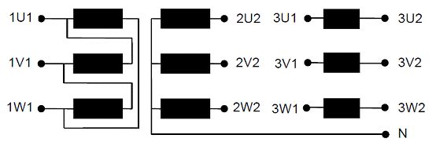
Figure1: Phase-angle regulation transformer with terminal designations for the experiment Procedure
First, a mixed ohmic/inductive load is to be supplied via two parallel-connected overhead line models. In this experiment, the feeding transformer is supplied on the primary side with 380 V (line-to-line voltage). The transformer can thus supply either one of the lines with an additional voltage of about ± 28 V at angles of 0° (in-phase regulation) as well as ± 60° and ± 120° (phase-angle regulation).
The inductive component of the load is identical in all experiments, and formed by three inductances of 3.2 H in a delta connection. The value of the resistive load (in a star connection) is readjusted during each experiment so that the load has a constant, total power consumption of 500 W. This makes the results easily comparable. Three multimeters can be used to simultaneously measure all voltages and currents, as well as active, reactive and apparent powers on both lines and the load.
Measured first is the power distribution without transformer regulation.
- Make the circuit as follows
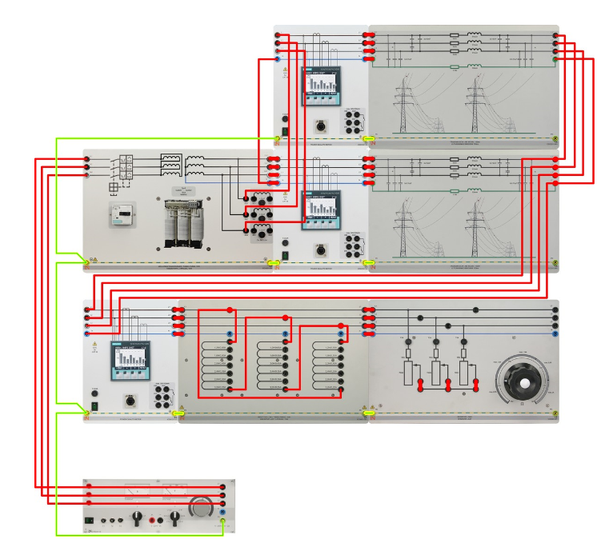
The figure shows the experiment circuit's basic layout. Only the main winding is used on the secondary side here. The terminals for the two overhead lines are illustrated. As previously mentioned, the load comprises a parallel connection of ohmic and inductive resistances (3 x 3.2 H in delta configuration; the load resistance is readjusted to result in a total power consumption of 500 W).
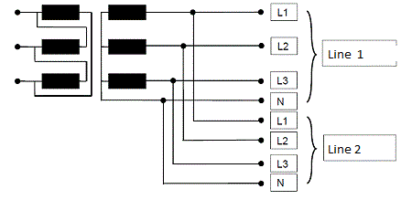
Figure 2: Connection of the two lines to the transformer without regulation
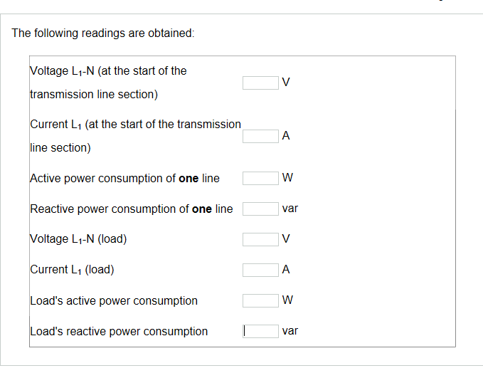
Expectedly, the current is distributed equally among both lines.
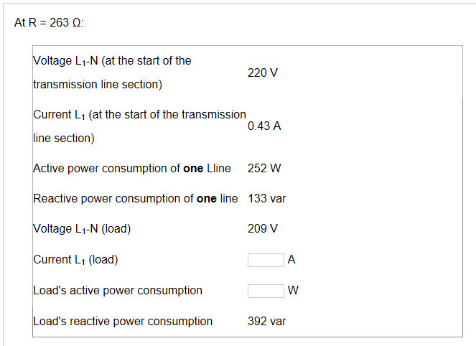
Experiment No: 12
Voltage Regulation in a Transmission Line
The individual windings of three-phase transformers can be configured in a delta (identifier D) or star (identifier Y) circuit. Whereas in the case of a delta circuit, the full, external line-to-line voltage is present across a winding phase, in the case of a star circuit a winding phase is loaded only with the star voltage (UN / √3). Though this reduces insulation expenditure, it also requires larger copper cross-sections because of the higher currents. Star connections are used preferentially for high and extra-high voltages.
Transformers with galvanically isolated windings for both voltage levels are known as separate-winding transformers. Another configuration option comprises an economy circuit, in whose case the high- and low-voltage windings exhibit a common part called the parallel winding. Another winding part, associated only with the high-voltage side, is called the series winding. Both partial windings are connected in series and inductively coupled. The economy circuit is identical to that of an inductive voltage divider, though able to step voltages not only down but also up. Autotransformers are identified additionally by the letter 'a'.
Short-circuit
- Make the Circuit given below
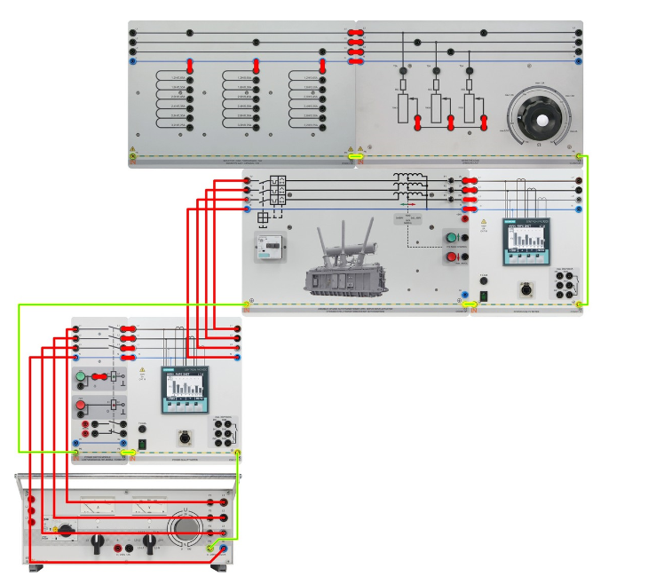
Observations and Calculations
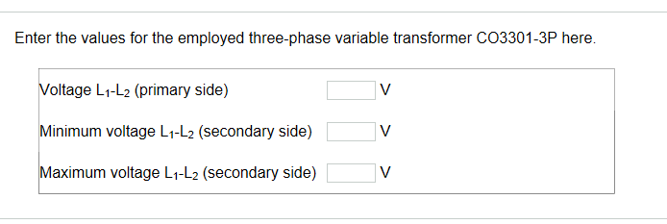
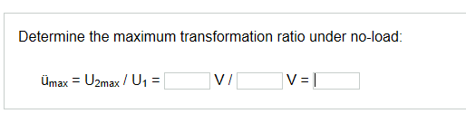
Overhead line 150 km long
- Make the Circuit given below
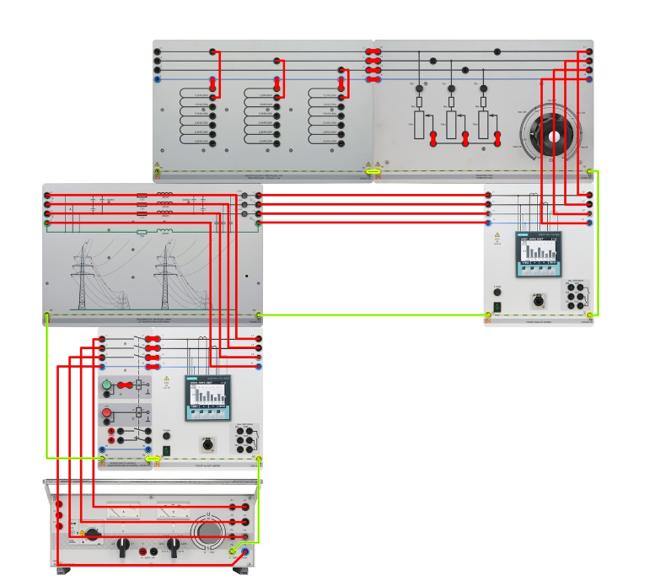
- Supply the line model directly from a desktop transformer CO3301-3Z with U_{L-L}=380 V; set the model to a length of 150 km.
- Connect a mixed resistive/inductive load to the line's end and repeat the test.
- Select a value of 1.2 H for L (in a star configuration).
- Due to the high current consumption, connect the resistive load in this and all following experiments in delta mode, and change the resistance (starting from the maximum value!) until the active power consumption is 600 W.
- During experiments with a line length of 150 km, make sure to use overlay mask CO3301-3AA for line model CO3301-3A.
Observations and Calculations:
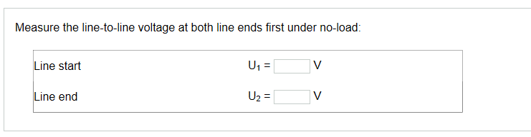
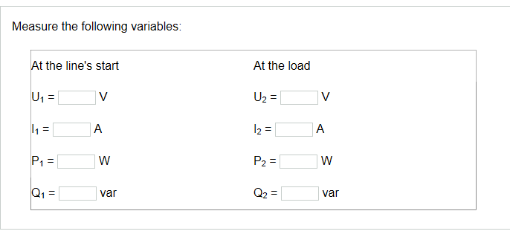
Line model 150 km long with a three-phase variable Transformer
- Modify the circuit as follows:

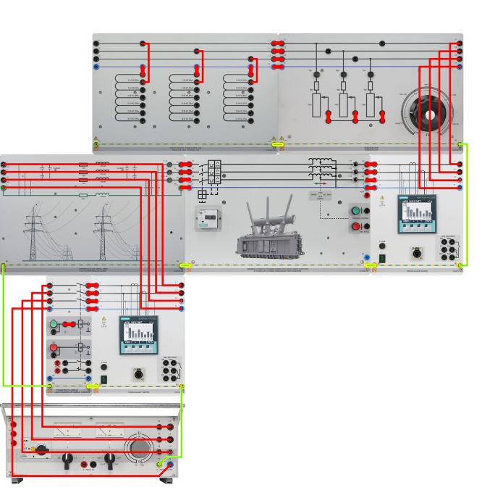

Perform a measurement under no-load beforehand to set the transformer initially to a ratio of 1.
Connect the mixed resistive/inductive load to the line's end once more (adjust L = 1.2 H and R again until the resistive load consumes 600 W).

Observations and Calculations:
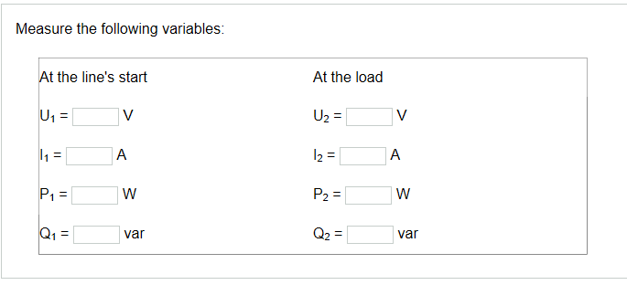
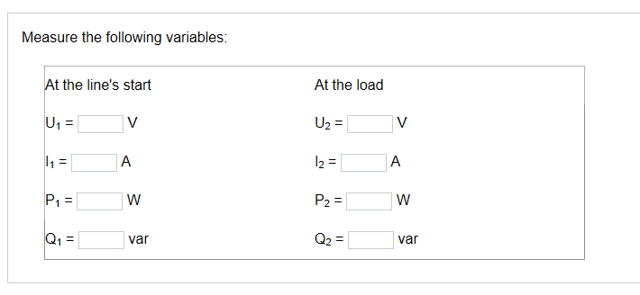

Experiment No 13
Single Bus-Bar Operation of a transmission line with one or two incoming feeders.
Electrical energy is transmitted and distributed via overhead lines and underground cables operating at different voltage levels, selections here being based on technical and economic criteria. To achieve high availability, it is necessary to mesh networks to an appropriate degree ensuring dependable energy supply for consumers even in the event of failure of individual transmission paths.
Points inside a network where two or more lines meet are called nodes. Often present at these nodes are switching devices which isolate affected phases for the purpose of eliminating faults or performing maintenance and repairs. The switching facilities needed for this, including measurement, monitoring, protection and ancillary equipment, are arranged spatially to form what is known as switchgear. If the switchgear includes transformers for changing voltage levels, one speaks of a substation.

Busbars
At the core of a switchgear installation is the busbar whose design depends on the operating voltage as well as currents expected during normal operation and in the event of faults. One possible design comprises solid copper bars (Figure 1). These are often used in the low-voltage range, but also for some medium-voltage applications.
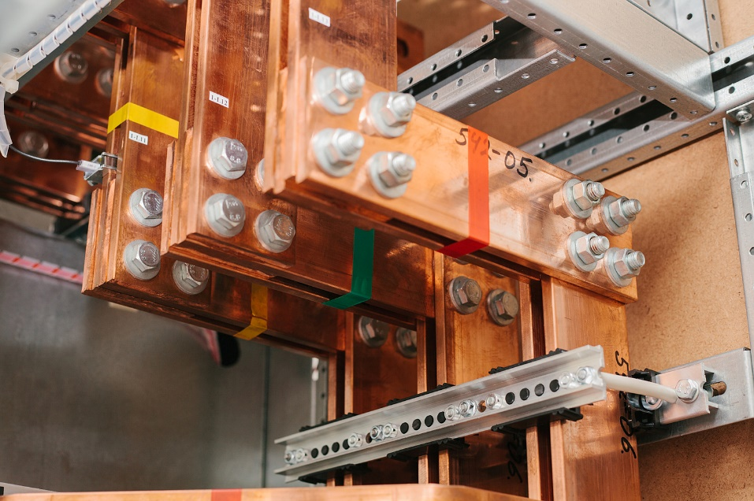
Figure 1: Solid copper busbars in the low-voltage range in an indoor switchgear cabinet. Due to the relatively low voltages, the three outer conductors (here: yellow, green, red) are only a few centimeters apart from each other.
At higher voltages, a use of solid conductors is avoided due to the skin effect; installed instead are hollow conductors usually shaped like tubes. In extreme cases, they can even be cooled internally to allow very large currents. Figure 2 shows three outer conductors incorporating wound and straight hollow tubes which are interconnected via a transducer.
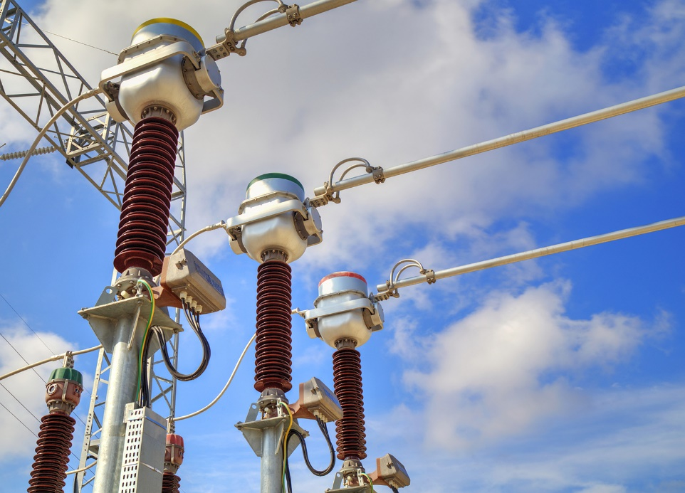
Figure 2: Three outer conductors (yellow, green, red) routed via transducers. Wound and straight hollow tubes are used here.
Figure 3 shows a cost-effective, large-scale and commonly used outdoor installation with hollow tubular conductors. The conductors run at a height of several metres above the ground (visible continuously from left to right in the picture). The hollow conductors are supported by insulators on the ground, otherwise air serves as the insulation path over appropriate intervals. Incoming and outgoing feeders at this kind of facility are connected to the hollow tubular conductors via scissor-type isolators/pantograph isolators (and circuit breakers). Running crosswise above the hollow tubular conductors are overhead lines connected to the upcoming pylons and establishing the link to the switchgear.
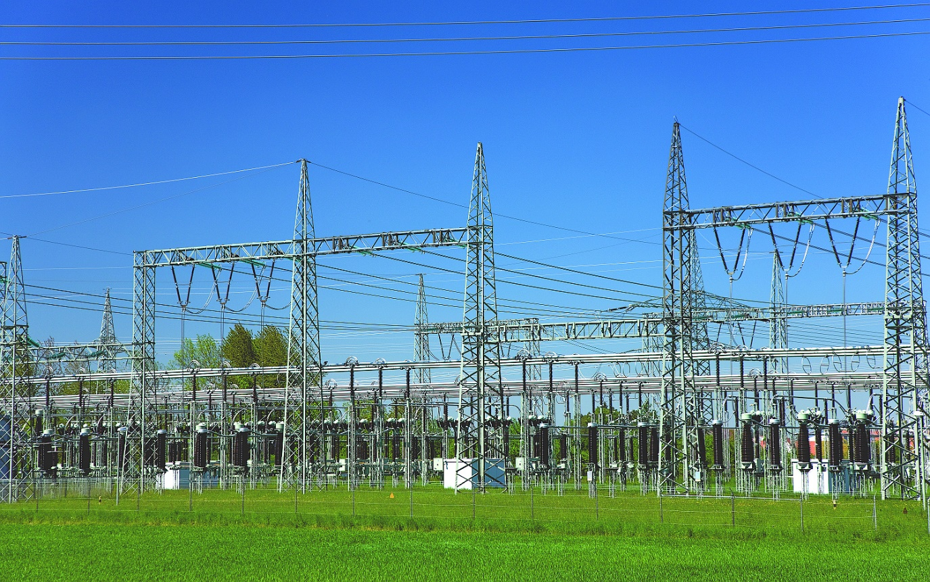
Figure 3: Outdoor switchgear with hollow tubular conductors and overhead lines
If the facility has to be more compact, and perhaps even be integrated into a residential/utility building, it requires gas-tight encapsulation. Encapsulation allows atmospheric air, which is quite conductive by comparison, to be replaced with a gas mixture comprising SF₆ (sulphur hexafluoride) which is a better insulator. This has a lower breakdown tendency, and allows the distances between the various potentials to be significantly reduced, thus enabling installation inside rooms and cabinets. Due to the gas apparatus, additionally required control mechanisms etc., such facilities entail higher equipment and maintenance costs.
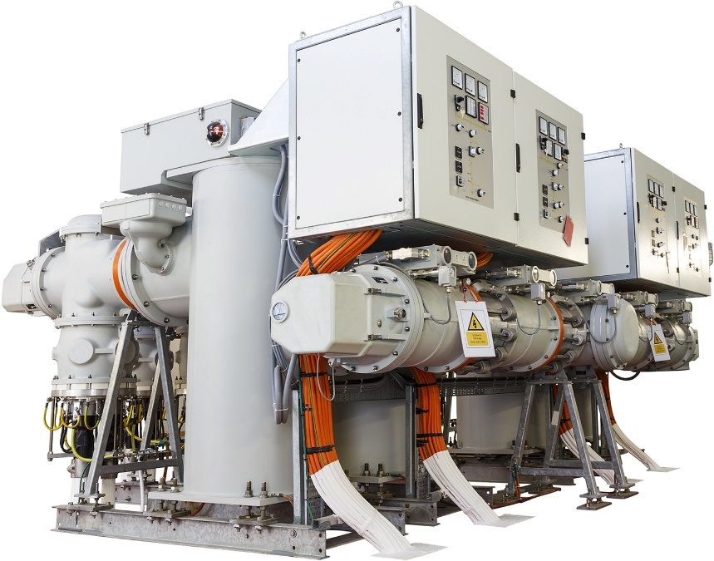
Figure 4: An indoor unit encapsulated in SF₆ (Sulphur hexafluoride). The picture shows all components such as busbar, circuit-breakers, isolators and control panel

Circuit breakers and isolators
Switching operations as part of high-voltage technology require elaborate switches for disconnecting the electric circuits. Capable of disconnecting the full operating current, as well as the fault current in the event of a fault, these switches are known as circuit breakers. Modern circuit breakers with the high-voltage rating of 380 kV, for example, can switch 80 kA reliably and non-destructively.
Figure 5 shows the sectional model of a circuit breaker with a low oil content. One arm of the circuit-breaker is able to switch 110 kV; the series arrangement of two switches (Y-shaped here, the second arm being visible on the right) doubles the switching capacity to 220 kV. The total short-circuit switching capacity is 1.3 GW, or nearly 6 kA. The oil forming part of the design serves for cooling and suppressing electric arcs during switching. Despite the greater tendency to use vacuum switches and SF₆ switches today, the fundamental principle has not changed: The resultant electric arc is cooled to induce a renewed breakdown of the already ionized air and/or confined to certain areas of the switch in order to lengthen the arc's path (serves to increase the reverse voltage). Usually, the electric arc is then extinguished at the first zero crossing of the source voltage.
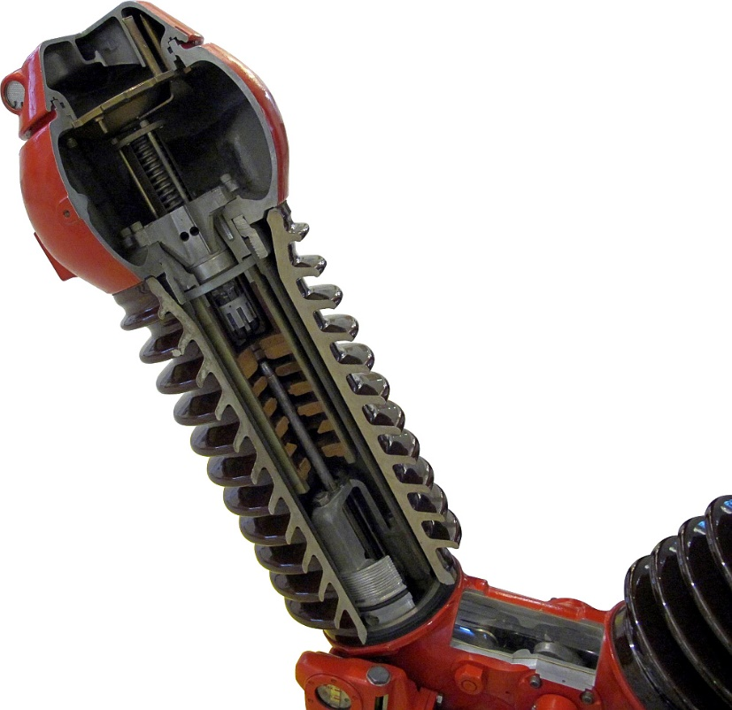
Figure 5: Sectional model of a 220kV circuit breaker with a low oil content (no oil is visible, due to the sectional view)
Isolators are used as a supplement to the relatively small, open spark gap of a circuit breaker. In the simplest case, they comprise a conductive blade which possesses a rotary bearing and which can be swivelled into a contact fitting. Isolators ensure reliable disconnection, also in the event of overvoltages, short circuits and lightning strikes; furthermore, their switching status is indicated optically or through inherent design.
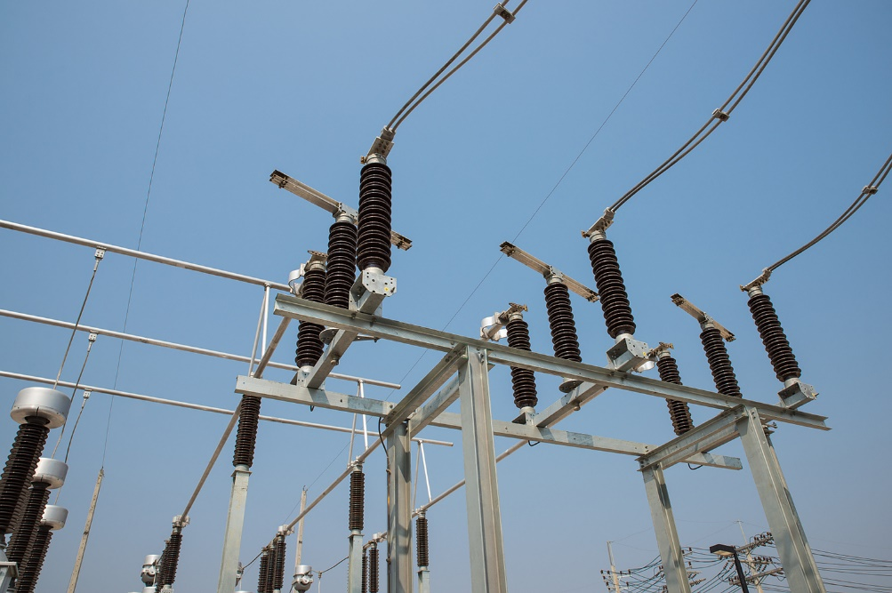
Figure 6: Pivoted, open isolators
Isolators allow maintenance to be performed safely at the facility. In contrast to a circuit breaker, an isolator may only be actuated in the de-energized state, i.e. the associated circuit breaker must be open. To avoid false switching, the isolator and associated circuit breaker of encapsulated facilities are mechanically Interlocked. The isolator also serves to produce a visible disconnection point, which is invisible in the case of circuit breakers because it is situated in an arc chute. The visible disconnection point is a required measure when de-energizing line segments, and serves for safe work on switchgear.

Arrangement of the assembly groups
According to its various functions, every switchgear facility and substation is divided into individual fields. A distinction is made here between incoming-feeder, outgoing-feeder and coupling fields.
The layout of each field is largely standardized. These fields are generally represented in single-pole mode in circuit diagrams. In this kind of representation, only the resources needed for the facility to function are drawn using standardized symbols:
Move the mouse pointer over Figure 7 to learn more about the individual components of the double busbar.

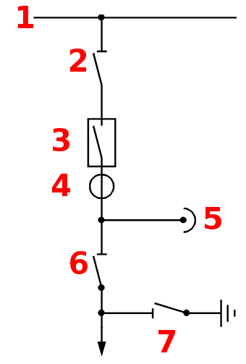
Figure 7: Block diagram of a branch (1. busbar; 2. busbar disconnector; 3. circuit breaker; 4. current transformer; 5. voltage transformer; 6. overhead line disconnector; 7. earthing disconnector)
The circuit shown in Figure 7 applies equally to incoming and outgoing feeders. The two isolators are used to disconnect the circuit breaker, including the current and voltage transformers. If the facility has several busbars, multiple busbar disconnectors are accordingly needed too, as shown for two busbars in Figure 9. The transformers register the data required by systems for operation, metering and protection.
Disconnected lines must be earthed for maintenance work on high-voltage installations. Neighbouring, active lines exert capacitive and inductive influences, while lightning strikes and other voltage sources are also possible; without earthing, it is therefore unlikely that the disconnected line is at earth potential. Due to its function, the earthing disconnector is also sometimes known as "earthing for work". Figure 8 shows the circuitry of a simple facility consisting of one busbar, one incoming feeder, and two outgoing feeders.
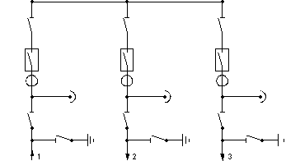
Figure 8: Facility with busbar, incoming-feeder field and outgoing-feeder field

Normally, at least two busbars are operated in parallel to allow large sections to be disconnected in the event of a fault or when work is needed.
For the sake of clarity, Figure 9 and subsequent illustrations no longer show the current / voltage transformers or overhead-line / earthing disconnectors.
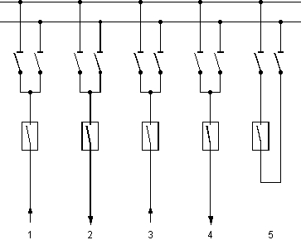
Figure 9: Facility with two busbars and coupling field
With the help of the circuit breaker in the coupling field, the two busbars can be connected to form a single node. This coupling is known as transverse coupling, and allows busbars to be changed without interruption. According to requirements, incoming-feeder fields and outgoing-feeder fields can be connected to the individual busbars without any interruptions in supply.
Because isolators can only be switched in the de-energized state, a circuit breaker is needed for coupling two busbars. If the busbars in Figure 9 need to be coupled together, the two isolators should be closed first, followed by the circuit breaker
During coupling of busbars, appropriate measures (e.g. adjustment of transformer step switches) are needed to equalize potentials, otherwise excessively high compensation currents flow when the busbars are interconnected. Once the busbars have been coupled, the branches can be switched back and forth between the busbars as required, because there is no longer any potential difference. Before an isolator is opened, it is simply necessary to ensure that the other isolator of the same branch is first closed. Otherwise an isolator would be opened under load and thereby get damaged, besides possibly causing further damage to the facility. Appropriate interlocks (electric or pneumatic) are used to secure the isolators against accidental opening.
If the facility shown in Figure 9 is to be extended to three busbars, only three instead of two isolators need to be installed per branch. As the number of busbars increases, so does the flexibility in achieving the desired network configuration. Transfer busbar is the term used for an additional busbar which is connected via a separate circuit breaker or a coupling field to the remaining busbars (Figure 10).
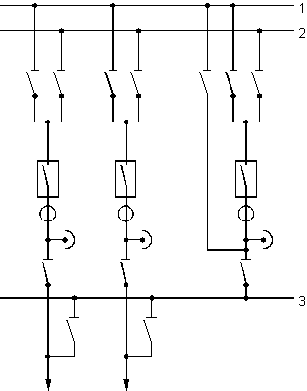
Figure 10: Facility with two busbars and a transfer busbar
At this facility, the equipment situated between the busbars and the transfer busbar can be disconnected for the purpose of inspection, without a need to open the relevant branch. This also applies to the current and voltage transformers in the configuration shown in Figure 10. During operation with a transfer busbar, the transformers and protective relays in the branch containing this busbar must therefore perform the protection and measurement tasks for the associated line. However, this is only possible if transformers possessing identical transformation ratios are installed in all branches. If this condition cannot be met, the current and voltage transformers must be situated behind the transfer busbar (on the line side). But this in turn hinders an inspection of these devices. Large facilities often incorporate a further switching option enabling longitudinal disconnection of long busbar systems. Termed longitudinal coupling, this option can be combined with transverse coupling as shown in Figure 11.
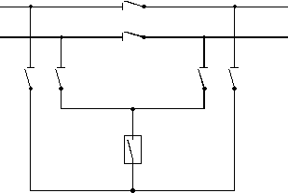
Figure 11: Coupling field with longitudinal and transverse coupling
Though very elaborate, this coupling with six isolators offers a multitude of circuit variants. It permits both busbars to be linked longitudinally, besides allowing transverse couplings in the left-hand or right-hand busbar section. Other embodiments of busbar couplings are also available depending on operational requirements. The equipment and related switching connections described above constitute only one of the facility's parts needed directly for operation. They are supplemented by other components such as surge arresters, earth-fault quenching coils, choke coils and coupling capacitors for transmitting carrier frequencies in high-voltage lines, and often also facilities for reactive power compensation.
To study the relationships applicable to switchgear, we will set up the training workplace shown in Figure 1 and basically allowing the switching operations described in the chapter on the basic circuitry of a double busbar model. To fully utilize a double busbar system's capabilities, it would be practical to supply each busbar from a separate voltage source. However, this would require installation of a synchronization mechanism upstream. The circuit in this experiment is fed by a single power source.
To achieve different loads for the individual busbars and produce a compensation current via the coupler panel, one busbar can be tapped before the line model, the other busbar after the line model.
Make the circuit diagram as shown in the following figure.
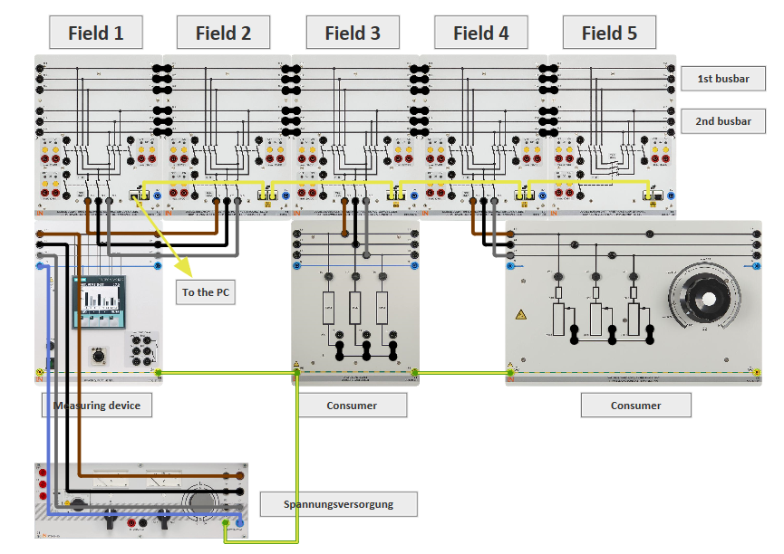

Single busbar operation with one incoming feeder: Switch ON (for example, switch on a consumer).
All isolators and circuit-breakers of the double busbars should be open at the beginning of each experiment.
In this experiment, we will perform switching operations for each individual field, the switching commands being provided before the following questions in each case. After every switching operation for a field, the switch position is verified by providing the correct answer to the respective question.
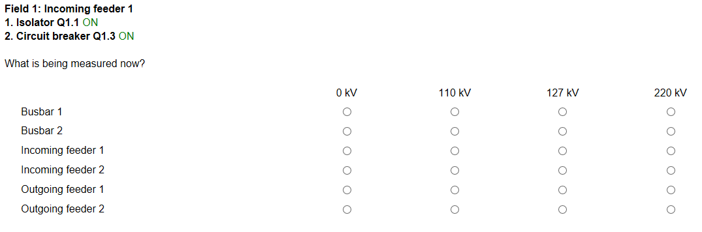
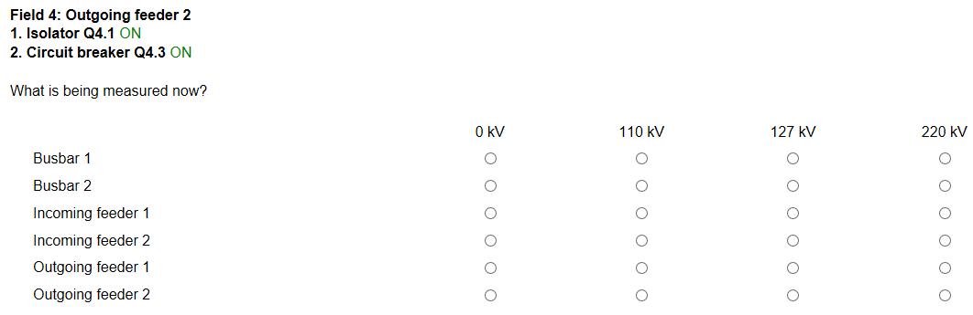
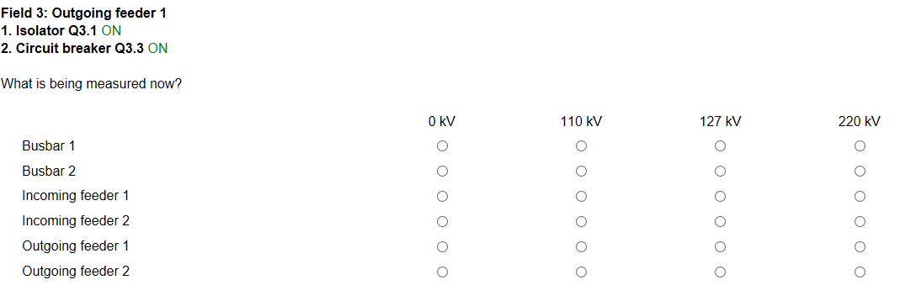
Single busbar operation with two incoming-feed transformers: Switch ON (e.g. by connecting two different loads fed by two voltage sources).
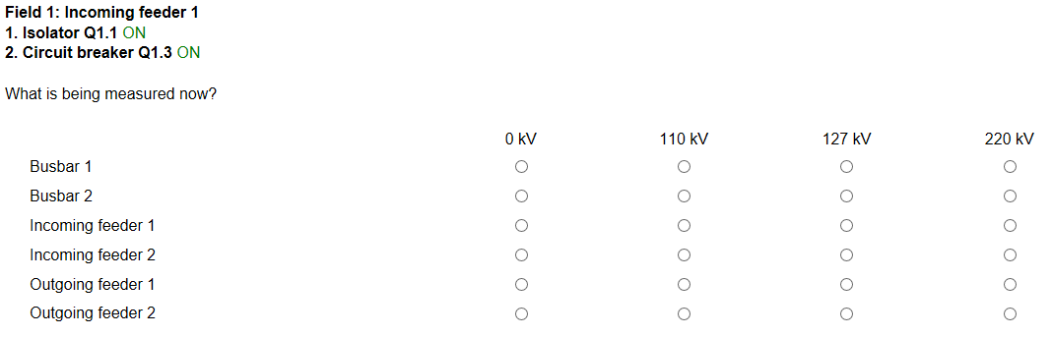
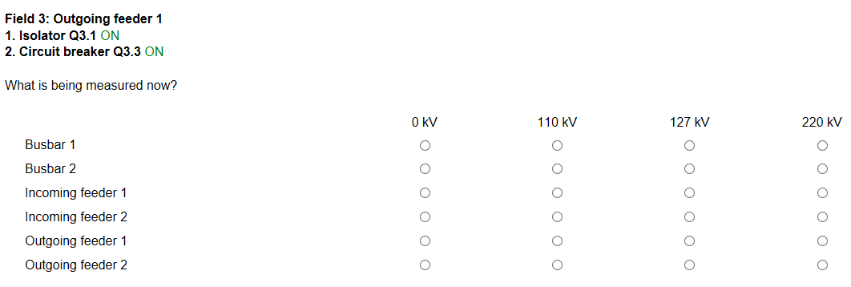

Experiment No 14
Double Bus-Bar Operation of a transmission line with one or two incoming feeders.
Make the connections as shown in the circuit diagram.
Double busbar operation with two incoming feeders: Switch ON (for example, by connecting several loads supplied by two voltage sources; in this process, the load current is distributed among several busbars).
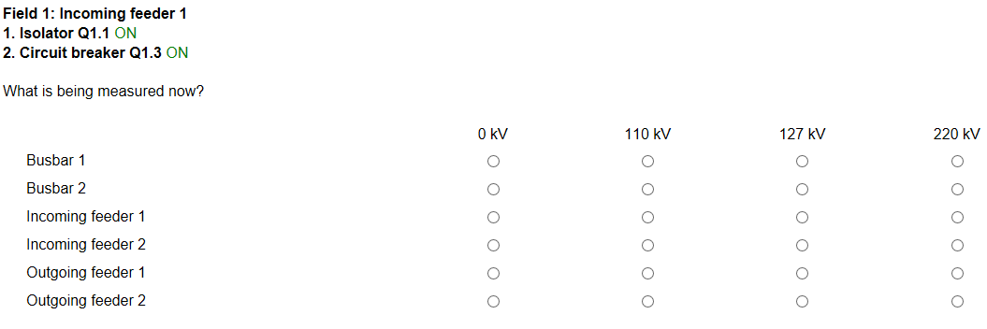
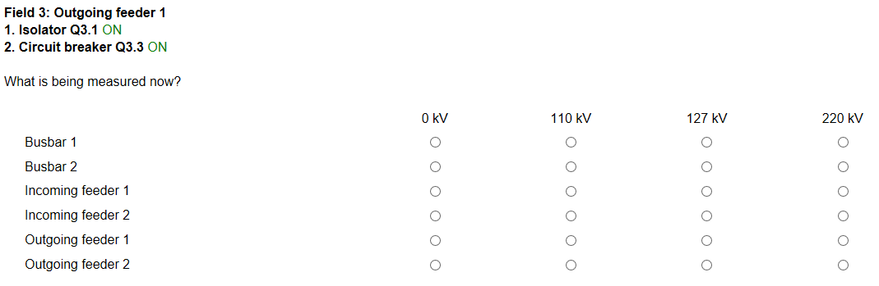
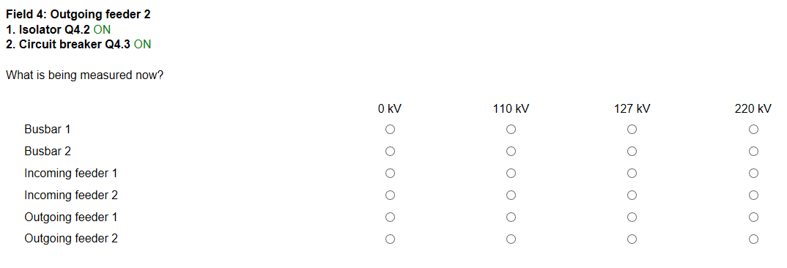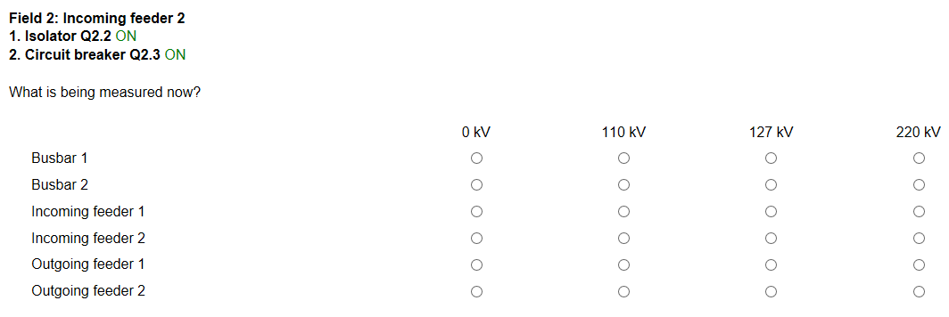

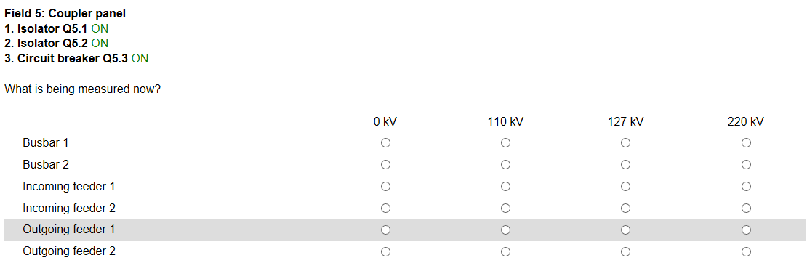
Experiment No 15
Investigating a change in Bus-Bar without interruption.
Make the connections as shown in the circuit diagram.
Busbar change without interruption: Switchover (for example, switchover of several consumers to a different busbar without interruption for the purpose of performing maintenance in the de-energized state without disrupting ongoing operations).
